

Municipal Recycling Progress Report Assistance Guidelines for Regional Solid Waste Facilities

Maine law requires all municipalities to report biennially on their progress towards helping the State of Maine reach our statewide recycling and composting goal of 50% diversion (see 38 M.R.S. §2132 “State goals” and 38 M.R.S. §2133 “Municipal recycling” included at the end of this document). The municipal recycling report is separate from the report that licensed transfer stations and storage sites must submit every year in accordance with 38 M.R.S. § 1310-N(6-D). See the annual solid waste facility report webpage at Applications and Forms, Transfer Stations and Solid Waste Storage Sites, Maine Department of Environmenta1l Protection for more information.

The municipal recycling progress report is due by April 30th on subsequent years. For example, the biennial report for calendar years 2019 and 2020 was due on April 30, 2021. The report for 2021 and 2022 will be due on April 30, 2023, and so on. Municipalities will be reaching out to their solid waste facilities for the data needed to complete the recycling progress reports. Your solid waste facility can help the municipality(ies) you serve complete their biennial recycling progress reports by providing them with annual summaries of how much MSW they generated and how that MSW was managed.

To complete a municipal recycling progress report, a municipality needs to know:

- How much MSW was generated within the municipality
- How much MSW was disposed via landfill or waste-to-energy incinerator
- How much MSW was diverted from disposal (for example, through reuse, recycling, composting, anaerobic digestion, etc.)

If your facility serves multiple municipalities, you may provide municipality-specific data in one of two ways:
  - Record the amounts of waste by municipality of generation upon receipt, and/or through annual hauler reporting to you, or

  - Follow the guidance in this document to apportion the waste management data recorded by your facility to the municipalities you serve.

Your goal is to provide the towns you serve with the best estimate of the amounts of MSW and recyclables generated per year within each municipality’s borders and delivered to your solid waste facility. If the information is available, you may also want to include this information on the amounts of construction and demolition debris received at your facility from various towns. Make it part of your standard services to provide this data to each municipality served by your facility every year.
- Record receipts by municipality of generation. If your facility is equipped with scales, the most accurate way to apportion amounts of MSW is to record the amount of waste as it is received by a municipality, i.e., as each load is weighed and entered into your data system. You can also record the generating municipality and whether the load was received for disposal or recycling. In some cases, local ordinances require a hauler that delivers MSW to a regional solid waste facility to report the tons of MSW including recyclables by each municipality of origin.
If delivering mixed loads from multiple municipalities, the hauler(s) may be able to provide you with the weight collected from each municipality or the total weight and percentage of MSW and recycling collected from each municipality in which they provide pick-up services. A sample cover letter and data form you can use to request recycling and waste tonnage information from haulers is available on Maine DEP’s website Municipal Recycling Progress Report, Solid Waste Application Fees and Forms, Remediation and Waste Management, Maine Department of Environmental Protection. If necessary, you can make this data form an annual requirement for haulers delivering loads to your facility. If you cannot apportion tons of municipal-specific data in this way, use the following guidance to apportion estimated tons to each municipality served by your facility.

- How to apportion the waste management data recorded by your facility to the municipalities you serve. The population of each municipality served by your facility is readily available information that can be used to estimate how many tons each municipality was likely to have contributed to the total amount received at your facility. If you choose, you may also account for any significant differences between municipalities using:
  - seasonal population (may be helpful if there are a lot of seasonal residents)
  - property valuations (may be helpful if there are significant economic differences among communities served by your facility)
  - any other significant differences between municipalities such as the percentage of their MSW that is commercially generated - municipalities with significantly more commercial activity generate more tons per capita than those with little commercial activity
  - any other factor relevant to your particular facility, e.g., one municipality manages recyclables separately from your facility operations.

Once you determine which factors you want to use, you can apportion the annual total amount of waste sent for disposal and for recycling and provide the estimated contribution in tons to each town that uses your facility.

- How to use the year-round population to apportion waste disposal and recycling tonnage data to the municipalities you serve.

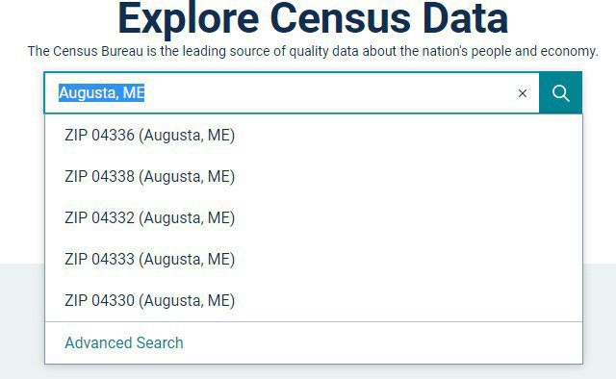
Step 1. Determine municipal populations served – First, find municipality’s year-round population on the U.S. Census Bureau Website’s at Census Bureau Data search by municipality name followed by a comma and “ME” or “Maine.” For municipalities with multiple zip codes as shown in the example to the right, do not select a zip code when search results show up; instead hit “enter” again to view population results for the entire municipality.
Step 2. Calculate percent of population in each town served – Next, use the Census numbers to figure out what percentage of the total population served by your facility lives in each town. For example, let’s say that a regional solid waste facility serves three municipalities.
Add up the populations of the towns using the facility to come up with a total. Then, divide each town’s population by the total population served.
Municipality | Population | % of Total  Population
A | 3,600 | 31%
B | 7,600 | 65%
C | 460 | 4%
Total | 11,660 | 100%

For example, municipality A has 3,600 people and the facility serves a total of 11,660 people. 3,600
÷ 11,660 = 0.31, so Municipality A makes up about 31% of the total population served by this regional facility. Use the same calculation to find the population served in each town:
  - Municipality B: 7,600 ÷ 11,660 = 0.65, so B makes up 65% of the population served
  - Municipality C: 460 ÷ 11,660 = 0.04, so C makes up just 4% of the population served
Step 3. Calculate tons of disposal and recycling per town by percent of population– In this example, the facility received a total of 3,800 tons of waste sent for disposal and 2,700 tons of waste sent for recycling during the reporting year. Each municipality’s waste generation can be estimated with a simple calculation:

  - Municipality A: 3,800 (tons disposal) x 0.31 (31% of population) = 1,178 tons of waste
  - Municipality B: 3,800 (tons disposal) x 0.65 (65% of population) = 2,470 tons of waste
  - Municipality C: 3,800 (tons disposal) x 0.04 (4% of population) = 152 tons of waste Similarly, each municipality’s recycling can be estimated using the same calculation:
  - Municipality A: 2,700 (tons recycling) x 0.31 = 837 tons of recycling
  - Municipality B: 2,700 (tons recycling) x 0.65 = 1,755 tons of recycling
  - Municipality C: 2,700 (tons recycling) x 0.04 = 108 tons of recycling

Your facility may receive other materials that cannot be directly traced to individual municipalities, such as leaf and yard waste, scrap metal, food scraps, or construction and demolition debris (CDD). A similar formula can be used to apportion tonnage from other materials received at your facility to the towns your facility serves.

- How to use other optional factors such as seasonal population and property valuation to apportion waste to the municipalities you serve.
Optional Factor 1: Account for Seasonal Population - If any of the towns using your facility have large seasonal populations, it may be helpful to factor these seasonal residents in when allocating the tons of waste and recycling generated by each community.
Step 1. Determine the average number of people per household - First, visit the Maine Housing Authority’s Housing Data interactive map on the website Data Portal | State of Maine Housing Data Portal
- Click the “Average household size” under the map on the right-hand side of the hovering your mouse over the county(ies) of your choice you will see the average of people per household. For example, Androscoggin has an average of 2.33 people per household.

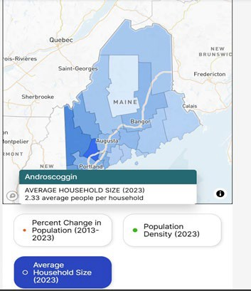

Step 2. Find the number of vacant seasonal housing units in each municipality
Select the County you want to view and click “generate detailed report” in the upper right corner.
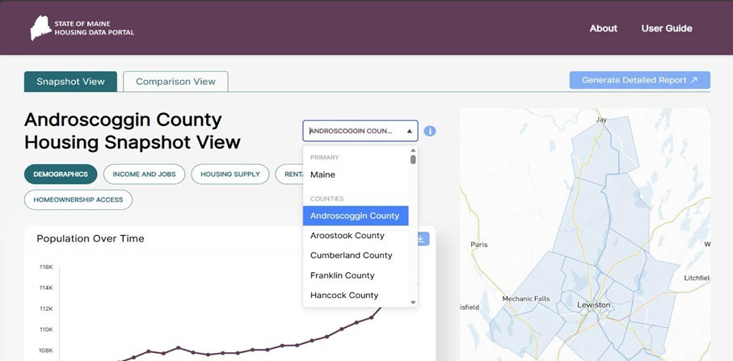

  - The detailed report will open in a new web browser window. Click on “Housing Supply Trend” in the left-hand menu and then select “Seasonal Vacancies”.

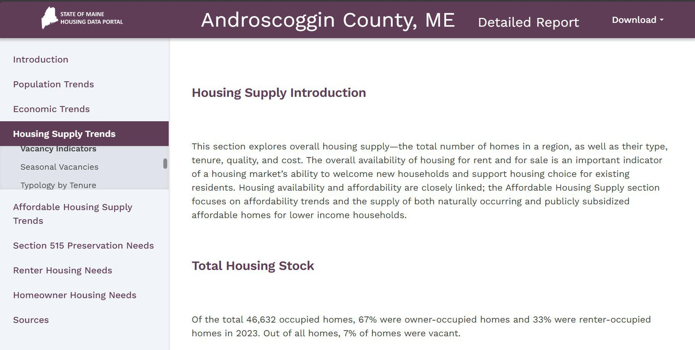
  - Next scroll down till you see the graph titled “Share of Homes That Are Vacant and Available Over Time”. Hovering your mouse over the bars will show the percentage and number of homes.

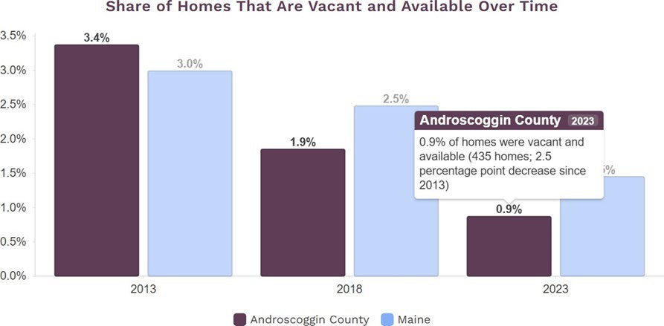

Step 3. Estimate each municipality’s seasonal population:
  - First, multiply the number of vacant seasonal housing units by the county’s average household size. This will give you an estimated number of seasonal residents.
  - Next, multiply the estimated number of seasonal residents by 33% or 0.33 to account for the fact that seasonal residents will generally spend only about one-third of the year (4 months out of 12) living in Maine.
    - In other words, 3 seasonal residents spending about one-third of the year in Maine are roughly equivalent to 1 year-round resident.
  - Add the adjusted number (# of total seasonal residents x 0.33) of seasonal residents to the year-round population for an average year-round population number that includes seasonal residents.
Sample Calculation to Estimate a Municipality’s Average Annual Population
1. First, calculate the total number of seasonal residents in the municipality: 435 (vacant seasonal units) x 2.33 (persons per household) = 1,013.55 seasonal residents
- Next, adjust the number of seasonal residents based on average time spent in Maine: 1,013.55 (seasonal residents) x 0.33 (percent of year spent in Maine) = 334.47 seasonal residents. Round the number of seasonal residents to a whole number. In this example, round up from 334.47 to 335
- Add adjusted seasonal residents to year-round residents for total estimated population: 335 (seasonal population) + 114,477 (year-round population) = 114,812
- 114,812 is the adjusted population number to use for this municipality

Optional Factor 2: Account for Property Valuation
If there are significant economic differences among the municipalities your facility serves, it may be helpful to use property valuation as a factor when allocating tons of waste and recycling generated by each community.
Step 1. Determine the property valuation for each municipality served by your facility – First, visit the Maine State Valuation website Property Tax | Maine Revenue Services

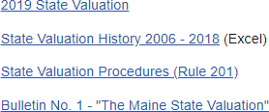
Once you have clicked on the link above and are on the Maine State Valuation website, find the link for the State Valuation History spreadsheet, which will be listed below the current year’s valuation. The link text will look like the screen capture shown to the right here, with the word “Excel” in parentheses following the document name.

Once downloaded, open the valuation history spreadsheet. The information is organized first by county and then by municipality in alphabetical order. Locate the county that the municipality is located within and then you will see the municipalities listed below the county name.
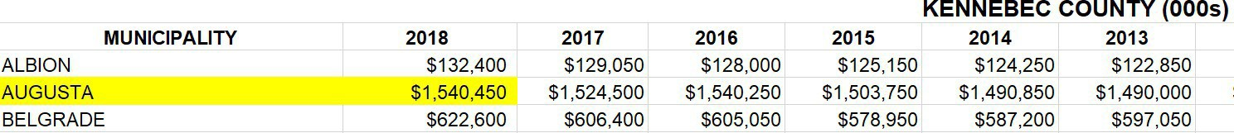
The valuation for the previous year will be shown next to the municipality name on the left side of the spreadsheet. Note that valuations are listed in the thousands (000s), so a listing of
$100,000 represents $100,000,000. For example, the highlighted information in the screen capture above shows the 2018 valuation for the City of Augusta, which is in Kennebec County, and is $1,540,450,000.
Step 2. Calculate percent of property valuation in each town served – First, add up the property valuations of each town using the facility. This example will demonstrate how a town with higher property valuation than the others using the facility may contribute more waste than would be expected based on population alone. Then, divide each town’s property valuation by the total property valuation for all the towns served by the facility.
For example, Municipality A has property valuation of $64,650,000 and the total property valuation of all the municipalities served by the facility is $219,050,000.
$64,650,000 ÷ $219,050,000 = 0.295, which means that Municipality A makes up about 30% of the total property valuation for all towns served by this regional facility. Use the same calculation to find the percentage for other towns:
  - Municipality B: $119,600,000 ÷ $219,050,000 = 0.545, or about 55%
  - Municipality C: $34,800,000 ÷ $219,050,000 = 0.158, or about 16%

The last step is to average the percentages for population and valuation:
  - Municipality A: (0.31 + 0.30) ÷ 2 = 0.3, or 30%
  - Municipality B: (0.65+0.55) ÷ 2 = 0.6, or 60%
  - Municipality C: (0.04+0.16) ÷ 2 = 0.1, or 10%

Municipality | Population | % of Total Population | Property Valuation | % of Total Valuation | Average % of Total Population &  Valuation
A | 3,600 | 31% | $64,650,000 | 30% | 30%
B | 7,600 | 65% | $119,600,000 | 55% | 60%
C | 460 | 4% | $34,800,000 | 16% | 10%
Total | 11,660 | 100% | $219,050,000 | 100% | 100%

Step 3. Calculate tons of disposal and recycling per town by population – Use the average percent calculated in Step 2 above that accounts for property valuation as well as population.
The facility received a total of 3,800 tons of waste and 2,700 tons of recycling during the reporting year. Each municipality’s waste generation can be estimated using a simple calculation:
- Municipality A: 3,800 (tons waste) x 0.3 (30%) = 1,140 tons of waste
- Municipality B: 3,800 (tons waste) x 0.6 (60%) = 2,280 tons of waste
- Municipality C: 3,800 (tons waste) x 0.1 (10%) = 380 tons of waste Similarly, each municipality’s recycling can be estimated using a similar calculation:
- Municipality A: 2,700 (tons recycling) x 0.3 (30%) = 810 tons of recycling
- Municipality B: 2,700 (tons recycling) x 0.6 (60%) = 1,620 tons of recycling
- Municipality C: 2,700 (tons recycling) x 0.1 (10%) = 270 tons of recycling
Your facility may receive other materials that cannot be directly traced to individual municipalities, such as leaf and yard waste, scrap metal, food scraps, or construction and demolition debris (CDD). A similar formula can be used to apportion other materials received at your facility based on population and valuation.
Optional Factor 3: Account for differences in commercial vs. residential waste generation
If your facility serves municipalities that differ significantly in the percentages of residential vs. business/commercial wastes generated (e.g., you serve several rural towns with insignificant amounts of business/commercial waste and one or two towns with significant commercial activity), you may want to apply a factor to attribute more waste per capita to the towns with the commercial activity. Your facility may have an interlocal agreement that dictates how you apportion such waste between towns. If you don’t, you may be able to work with haulers to develop estimated percentages of commercial vs. residential waste for the towns you serve. You may then apportion the total residential waste received by your facility based on the relative annual average residential populations, and the total commercial waste based on relative percentages of commercial activity.1

Optional Factor 3: Account for any other relevant factors
Since each municipality determines how it manages its MSW for disposal and recycling, there may be circumstances particular to your facility that can affect how you apportion MSW disposal and recycling. The most common situation may be that some of the towns that manage MSW disposal through your facility may manage recycling through a separate system. Because this is a facility-specific circumstance, you may want to adjust how tonnage is apportioned by taking any unique circumstances into account.

Background: Municipal Reporting Requirements

§2132. State goals
1.State recycling goal. It is the goal of the State to recycle or compost, by January 1, 2021, 50% of the municipal solid waste tonnage generated each year within the State.
1-B. State waste disposal reduction goal. It is the goal of the State to reduce the statewide per capita disposal rate of municipal solid waste tonnage to 0.55 tons disposed per capita by January 1, 2019 and to further reduce the statewide per capita disposal rate by an additional 5% every 5 years thereafter. The baseline for calculating this reduction is the 2014 solid waste generation and disposal capacity data gathered by the department.

§2133. Municipal recycling
1-A. Recycling progress. Municipalities are not required to meet the state recycling goal in section 2132, but they must demonstrate reasonable progress toward that goal. The department shall determine reasonable progress.
7. Recycling progress reports. Municipalities shall report biennially, on forms provided by the department, on their solid waste management and recycling practices. The biennial report must identify the options available to residents and businesses within the municipality for managing solid waste, including any provisions for the separate management of reportable recyclable materials and organic waste and the disposal of other municipal solid waste, including construction and demolition debris. The department shall assist municipalities in developing and tracking a municipal or regional recycling rate by developing a municipal waste stream management assessment model. The model must rely on actual waste data whenever possible but incorporate default generation estimates when needed. Default generation estimates must incorporate factors such as commercial activity, geographical differences, and municipal population.

1 If any of your municipalities have significant commercial waste generation, you are welcome to contact Maine DEP recycling staff at 207-287-7688 to consult on how you may account for this when estimating waste generation.

