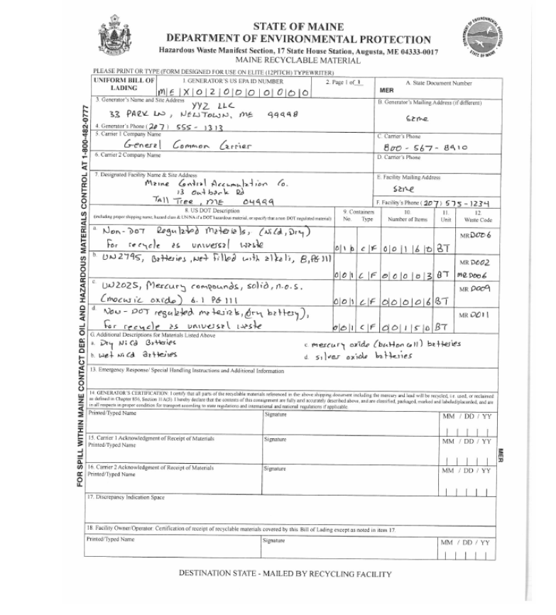
The photo above shows a completed example of a Uniform Bill of Lading.

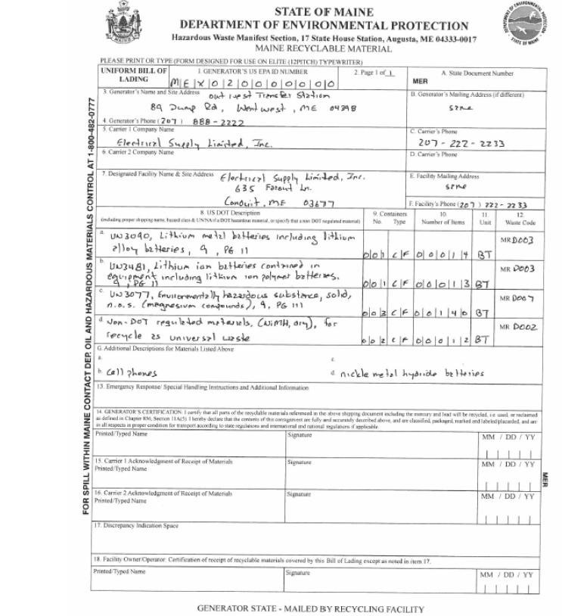
The photo above shows a second completed example of a Uniform Bill of Lading.

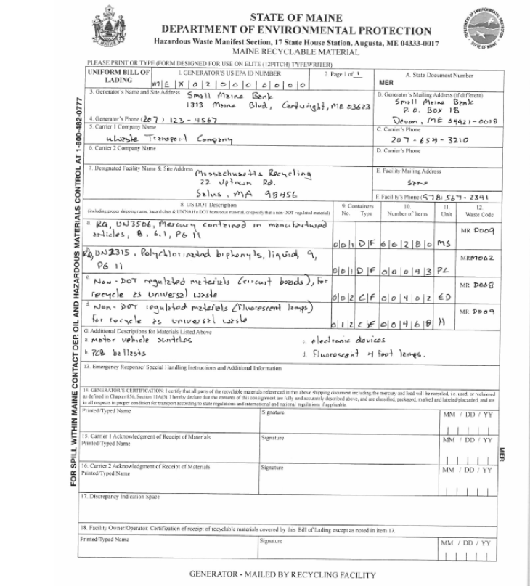
The photo above shows a third completed example of a Uniform Bill of Lading.

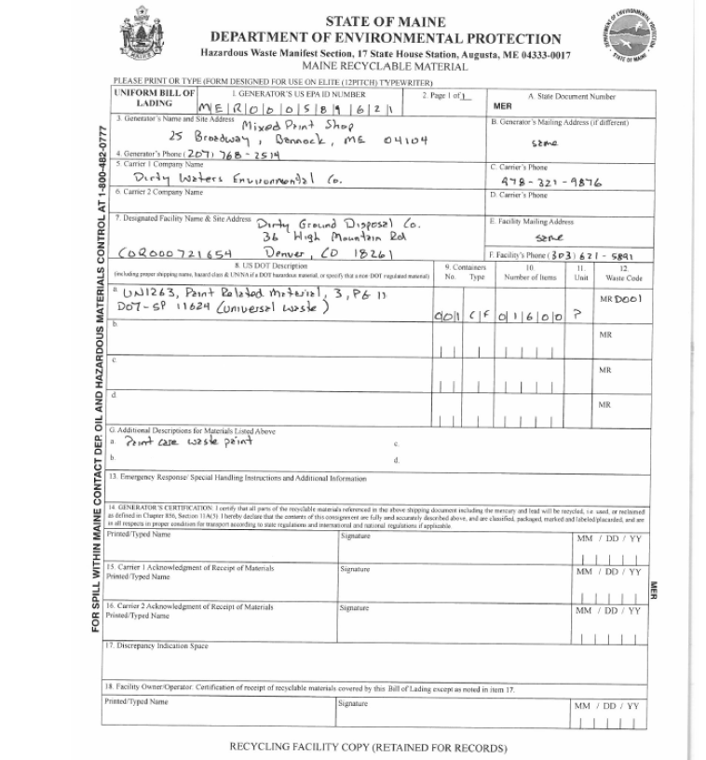
The photo above shows a fourth completed example of a Uniform Bill of Lading.

