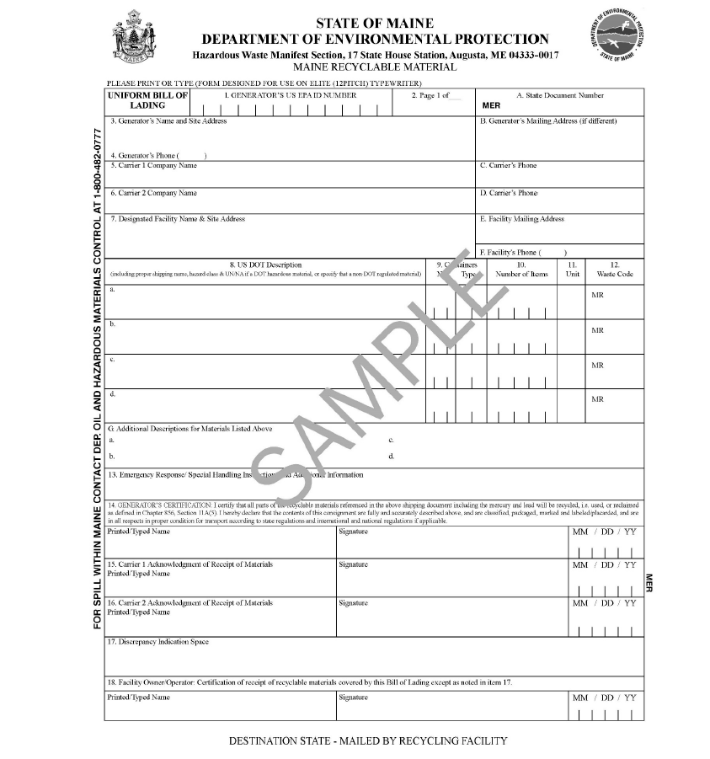
The photo above shows a blank sample of a state approved alternative shipping document for universal waste, a Uniform Bill of Lading, including the following information: generator or EPA ID, generator name, generator physical address, generator mailing address, generator phone number, carrier one name, carrier one phone number, carrier two name if applicable, carrier two phone number if applicable, designated receiving facility name, designated receiving facility physical address, designated receiving facility mailing address, designated receiving facility phone number, waste line descriptions that include details like number of containers, container type, number of items, waste type, and waste codes. There is a section below for any additional descriptions of the waste, a section for emergency response or special handling instructions, signatures and dates from all parties, and a section for discrepancies.
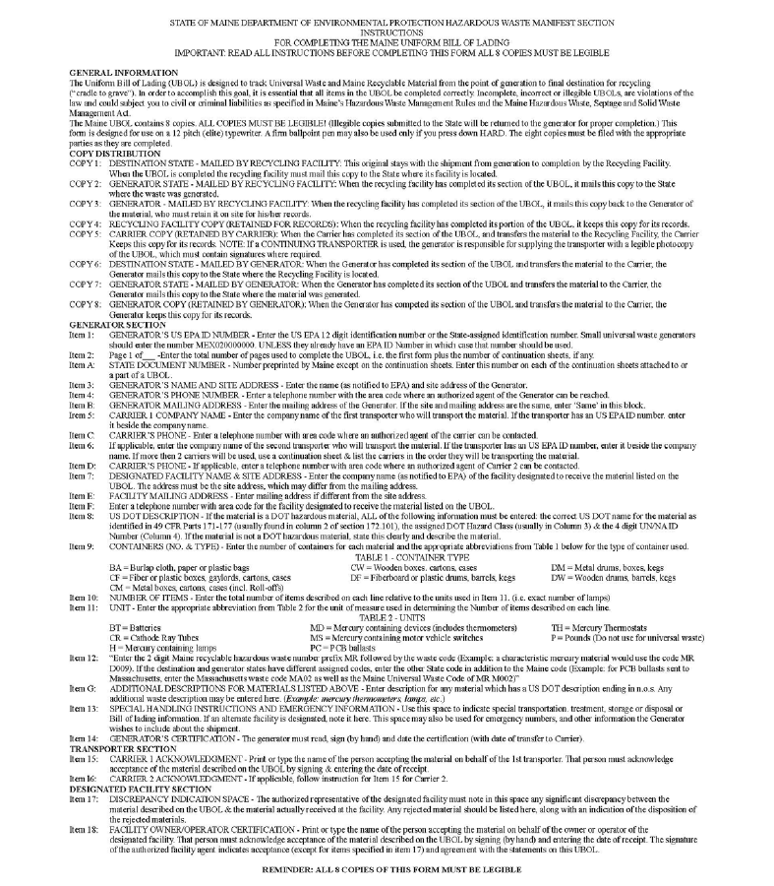
The photo above shows the instructions on how to fill out the Uniform Bill of Lading and where each copy should go. This information is found on the back of the Uniform Bill of Lading.

