WATER QUALITY ASSESSMENT
MEMORANDUM

TO: Laura Paye, Hydropower Coordinator, Bureau of Land Resources

FROM: Wendy Garland, Director
Division of Environmental Assessment, Bureau of Water Quality

DATE: February 19, 2025

RE: Lowell Tannery Hydroelectric Project Water Quality Assessment

This Water Quality Assessment Memorandum (WQAM) provides a summary of the Bureau of Water Quality’s Division of Environmental Assessment staff review of the Lowell Tannery Hydroelectric Project (Project) Water Quality Certification (WQC) application. Additionally, staff provided a preliminary assessment of whether the Project attains applicable State water quality standards and staff recommendations for WQC conditions or mitigation measures.
This WQAM is advisory in nature and does not contain any Department findings or constitute a Department action related to the Project WQC application. The Department’s WQC Order, signed by the Commissioner, will represent the Department’s findings regarding the Project’s attainment of water quality standards and will include any applicable conditions.

Project Description
On July 29, 2024, the Applicant applied to the Department for Water Quality Certification (WQC) pursuant to Section 401 of the CWA for the proposed relicensing and continued operation of the existing Lowell Tannery Hydroelectric Project, P-4202 (Lowell Tannery Project or Project), located on the Passadumkeag River in the Town of Lowell, Maine. The application was accepted for processing on August 7, 2024. The WQC application established a statutory one-year deadline of July 28, 2025, for the Department to complete its certification review and issue its decision.

Located approximately 13 river miles upstream from the confluence of the Penobscot River, the Lowell Tannery Project is the only dam on the Passadumkeag River. The Passadumkeag River is part of the Penobscot River watershed. The Lowell Tannery Project dam and original powerhouse have been in place since 1986.
The existing Lowell Tannery Project consists of a 230-foot-long, 27-foot-high concrete gravity dam with a crest elevation of approximately 178.8 feet topped with 3.5-foot-high flashboards (for a total of 182.3 feet normal pond elevation), with a principal spillway of 30 feet and an auxiliary spillway of 89 feet, a seven-foot-wide log sluice and a 10-foot-wide tainter gate. The Project impoundment is approximately 341 acres at elevation 187.5 feet mean sea level. The Project has upstream and downstream fishway passage facilities, consisting of a 3-foot-wide Denil fish passage facility and a dedicated downstream fish bypass pipe. A powerhouse integral to the dam contains a single turbine generator unit with a total generating capacity of 1 Megawatt (MW) and an average annual generation of approximately 4,095 Megawatt hours (MWh). The Project has a 200-foot-long transmission line and appurtenant facilities. The Lowell Tannery Project operates in a run-of-river mode, where upstream water flowing into the project impoundment approximately equals water flowing downstream from the project. The Project boundary includes the dam, powerhouse, four miles upstream, and approximately 250 feet downstream of the powerhouse
The Lowell Tannery Project operates as a run-of-river facility. The Project has an overall minimum flow requirement of 150 cfs (or inflow if less) minimum flow. The Applicant provides 40 cfs of attraction and conveyance water through the fishway from May 15 through November 10 annually; the fishway attraction flow is discharged near the base of the powerhouse. The Applicant provides a fishway flow of 20 cfs through the downstream bypass, which is provided through the stop log slot at the entrance. When river flow exceeds the powerhouse capacity, fish may pass with spill over the dam. KEI (USA) operates the downstream fish passage in the spring from ice-out through early June. Downstream passage for kelts is provided through the downstream fishway from November 1 to ice-in.
The Applicant proposes to continue operating the Lowell Tannery Project in a run-of-river mode. KEI (USA) proposes to eliminate the overall downstream minimum flow requirement of 150 cfs (or inflow if less) that is part of the current license. The Applicant proposes to continue to provide 40 cfs of attraction and conveyance water through the fishway from May 15 through November 10 annually; as well as a fishway flow of 20 cfs through the downstream bypass. When river flow exceeds the powerhouse capacity, the Applicant proposes to continue allowing fish to pass with spill over the dam.
Project Boundary Map
Applicable Standards
Water Quality Standards and the water quality classifications of all surface waters of Maine are established by the Maine Legislature (38 M.R.S. §464-468). The Passadumkeag River is classified Class A above the dam and Class AA below the dam.

Class A waters must be of such quality that they are suitable for the designated uses of drinking water after disinfection; fishing; agriculture; recreation in and on the water; industrial process and cooling water supply; hydroelectric power generation, except as prohibited under Title 12, section 403; navigation; and as habitat for fish and other aquatic life. The habitat must be characterized as natural.

Class AA waters must be of such quality that they are suitable for the designated uses of drinking water after disinfection; fishing; agriculture; recreation in and on the water; navigation; and as habitat for fish and other aquatic life. The habitat must be characterized as free-flowing and natural.
Water Quality Assessment
Division of Environmental Assessment (DEA) staff reviewed the WQC application and evaluated associated data to assess whether the Project meets applicable water quality standards. DEA staff assessments for each water quality standard are summarized below.
- Impoundment Aquatic Habitat
The Applicant must demonstrate that the Lowell Tannery impoundment is suitable for the designated use of habitat for fish and other aquatic life. Conformance with the aquatic habitat designated use is determined by methods described in the Department’s Hydropower Project Flow and Water Level Policy, dated February 4, 2002 (Water Level Policy). Under this policy guidance, the Department operates under the rebuttable presumption that a water level that provides wetted conditions for 3/4ths of the littoral zone of a lake or pond, as measured from full pond conditions, will be needed to meet aquatic life and habitat standards. On a case-by-case basis, the Department may approve alternative flows or water levels under circumstances defined in the Water Level Policy, where the alternative flows or water levels can be shown to meet all applicable water quality standards.
In the FLA, the Applicant provided monthly and annual average flow duration statistics for the Lowell Tannery Project using United State Geological Survey data from 2021. The data indicates that Project operations generally maintain consistent water levels and attenuate high-inflow events. Project operations limit impoundment water level fluctuations to approximately 1 foot of normal pond elevation for the Lowell Tannery impoundment. Given this information, the Project maintains 75% of the littoral zone in wetted conditions as measured from full pond, protecting habitat in the littoral zone.

- Impoundment Trophic State
The Applicant completed Impoundment Trophic State Studies in 2019. The Applicant completed a reconnaissance-level bathymetry survey prior to collecting the first lake trophic sample to identify the deepest, safely accessible spot in the Lowell Tannery Impoundment. That spot was approximately 20-feet-deep and 250 feet upstream of the dam. Lake trophic sampling was conducted twice per month for five consecutive months from June through October, primarily between the hours of 11:00 and 15:00.

Sample parameters included Secchi disk transparency (SDT), water temperature and dissolved oxygen (DO) profiles at 1-meter intervals, and epilimnetic core samples of total phosphorous, Chlorophyll-a, color, pH, and total alkalinity. Additional nutrient and dissolved metal samples were collected during the late summer sampling event on August 15, 2019. The additional later summer sample parameters included nitrate, dissolved organic carbon (DOC), total iron, total dissolved aluminum, total calcium, total magnesium, total sodium, total potassium, specific conductance, chloride, and sulfate. The late season sample was collected from an integrated epilimnetic core because the water column was not thermally stratified.
Water chemistry data is summarized in Table 3 (below). Total phosphorus in the Lowell Tannery impoundment ranged from 15 μg/L to 33 μg/L with an average of 20 μg/L. Color ranged from 85 PCU to 180 PCU with an average of 136 PCU. Chlorophyll-a ranged from 0.0020 mg/L to 0.0050 mg/L with an average of 0.0031 mg/L. The samples collected on June 25 and August 26, 2019 had values of 0.004 mg/L, and the sample collected on August 15, 2019 was 0.005 mg/L. The Secchi disk depth at the deep spot in the Lowell Tannery impoundment ranged from 1.9 meters to 2.9 meters with an average of 2.3 meters. Using the average chlorophyll-a concentration for the entire sampling period (0.003 mg/L), the TSI for the Lowell Tannery impoundment is 40.6, which is categorized as mesotrophic.
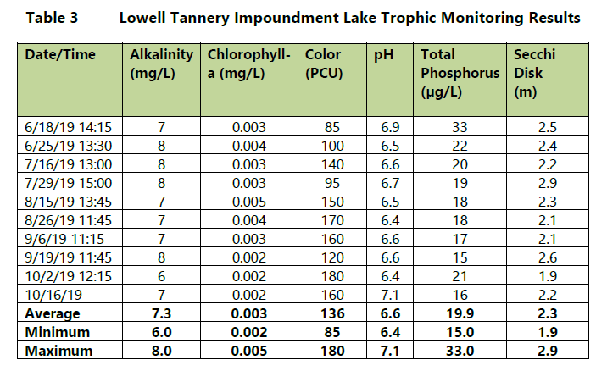

DO and temperature profiles indicate that the impoundments did not stratify. DO ranged from 6.3 mg/L to 7.3 mg/L with averages of 6.5 mg/L to 6.8 mg/L. DO generally increased in the
remaining profiles collected in September and October 2019 (range 7.1 mg/L to 9.2 mg/L);
the water column average was 9.0 mg/L in the last profile on October 16, 2019. Except for the August 26, 2019 profile when the range was 72.1 percent to 75.1 percent, all DO percent saturation measurements were above the standard for Class A waters (75 percent saturation).

Dissolved oxygen values in the impoundment are likely low due to the presence of high concentrations of Dissolved Organic Carbon (DOC), which is comprised of organic compounds that originate from the decomposition of plant and animal matter. High concentrations of DOC result in high color in surface waters. Color ranged from 85 -180 PCU with an average of 136 PCU, and the one DOC value obtained during the late summer visit was 16 mg/L. Both color and DOC concentrations are very high for a typical Maine lake or impoundment. DOC molecules are broken down by sunlight in an oxidative reaction, which consumes oxygen from the water. Thus, highly colored waters often experience low oxygen concentrations.

In addition, DOC molecules are complex and are able to sequester chemical elements rendering them biologically unavailable. The total phosphorus concentrations observed are higher than one would expect given the observed low to moderate chlorophyll-a concentrations; this suggests that some of the total phosphorus is associated with the DOC and biologically unavailable.

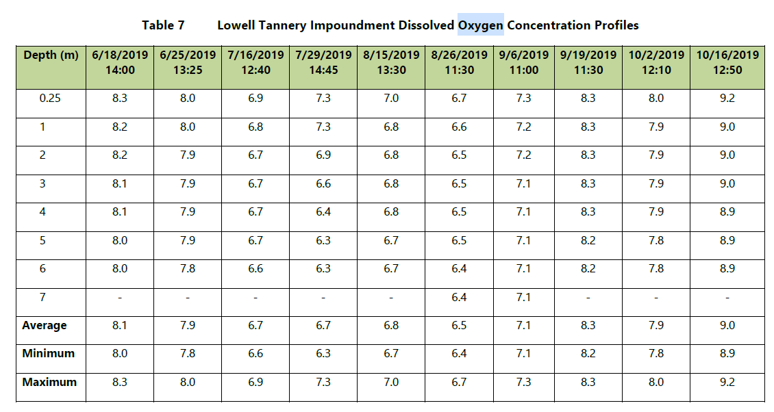

Based on the sampling results and information contained in the WQC application, the Project impoundment meets applicable Class A water quality standards and is free of culturally induced algal blooms. Trophic data indicate that that the waters are in the mesotrophic range. See below for further discussion of dissolved oxygen.

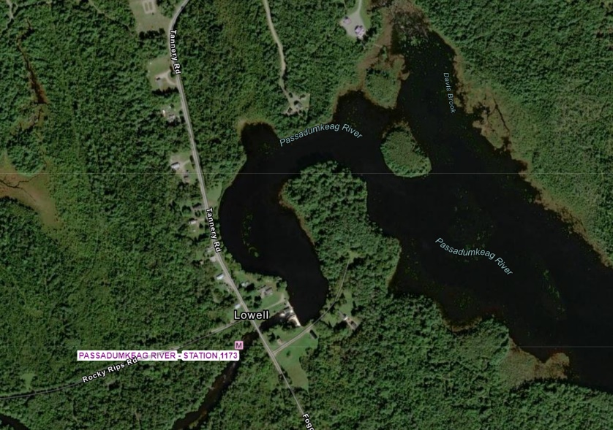
- Stream Aquatic Life
The applicant completed benthic macroinvertebrate sampling downstream of the dam consistent with MDEP’s Methods for Biological Sampling and Analysis of Maine’s Rivers and Streams.

The study included one sampling location, ~490 feet downstream of the dam. Macroinvertebrate rock bag samplers were deployed at the designated station on August 6, 2019, and retrieved 38 days later on September 13, 2019. Retrieval of the samplers was delayed beyond the standard deployment time due to high flows.

DEP staff analyzed resulting data using its linear discriminant model and found that the macroinvertebrate community at this site met aquatic life criteria for Class B. Consistent with MDEP’s Methods for Biological Sampling and Analysis of Maine’s Rivers and Streams, the final class attainment was raised to Class A due to lake outlet effect. Therefore, the macroinvertebrate community at this site attains its applicable aquatic life criteria.

Although there is no time to adjust the record, other comments are provided below:
- Page 4-30 The main findings of the water quality monitoring…first bullet states that “total phosphorus levels above the standard for Class A/AA waters (18 μg/L).” which is misleading as there are no actual P standards until the Nutrient Criteria are adopted.
- Section 4.8.2.1 Proposed Action also mentions Class A/AA P standards
- Section 4.9.1.7 Benthic Macroinvertebrates and Freshwater Mussels states that Section 4.8 discusses a BMI study done by the MDEP monitoring in 2016, but section 4.8 actually discusses the sampling done by Moody Mountain at S-1173 in 2019. Site sampled in 2016 is a considerable distance upstream, so I am not sure what relevance it has. Unless it was used as an upstream reference site but that is not mentioned

- Downstream Dissolved Oxygen and Temperature
In addition to the dissolved oxygen and temperature data collected as part of the trophic study, the Applicant conducted a continuous Dissolved Oxygen (DO) and Temperature Study at a single location approximately 200-feet downstream of the tailrace in accordance with the Department’s Sampling Protocol for Hydropower Studies from June 25 to September 17, 2019.
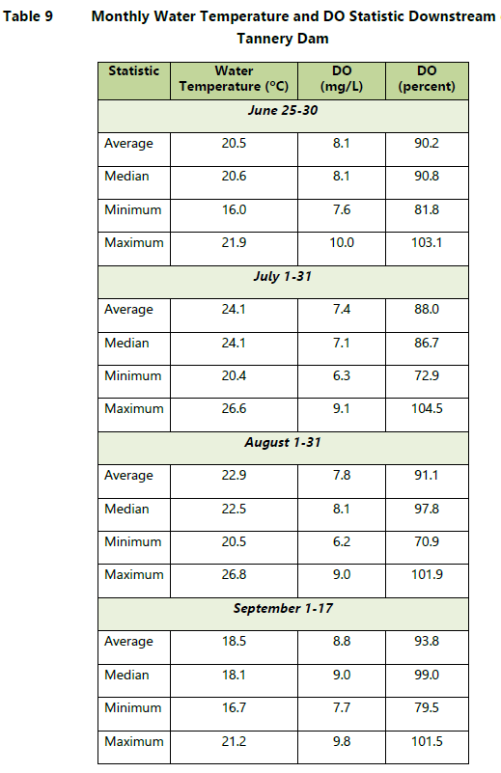
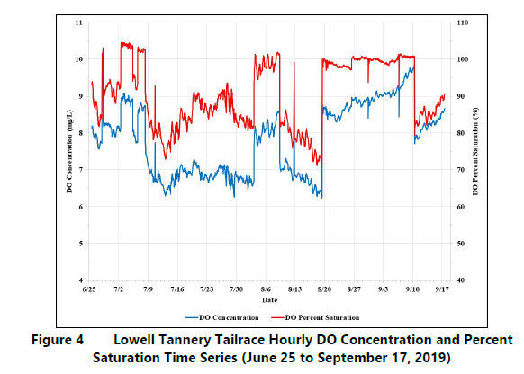
In late June 2019, the DO concentration and percent saturation ranged from 7.6 mg/L to 10.0 mg/L and 81.8 percent to 103.1 percent. The DO concentration ranged from 6.2 mg/L to 9.1 mg/L, and the percent saturation ranged from 70.9 percent to 104.5 percent in July and August 2019. In September 2019, the DO concentration ranged from 7.7 mg/L to 9.8 mg/L, and the DO percent saturation ranged from 79.5 percent to 101.5 percent.

The rapid increases and decreases in DO corresponded to times when the Lowell Tannery Project began and stopped generating (Figure 4). When generation stopped, DO levels downstream of the dam increased as a result of spill reflecting increased aeration and mixing (for example on August 3 and August 19, 2019). During times when the project was generating, the water temperature and DO measured downstream of the dam reflected the levels in the impoundment as demonstrated by comparing levels downstream to the impoundment profiles on June 25, July 16, July 29, and August 16, 2019.
The Applicant monitored DO and water temperature in 2020 to evaluate whether upstream waters (i.e., impounded waters or inflowing waters to the impoundment) may have contributed to the low DO values near the dam and in the tailwater that were observed in 2019. Between July 15 and August 24, 2020, continuous measurements were recorded at the following four locations: Upstream (3.8 miles upstream from the dam at the transition point between river and impounded habitat) The “Upstream” site is also near the outlet to Saponac Pond which is a naturally impounded body of water significantly larger than the Lowell Tannery Impoundment; Impoundment (deep hole ~250 feet upstream of dam); Tailwater (directly downstream of the dam); and Downstream (one miles downstream of the dam). Due to low river flows, KEI (USA) was not able to operate the project during the 2020 monitoring period; all water was spilled or passed through the fishways. As a result, the data from the tailrace site was not representative of conditions during project operations.

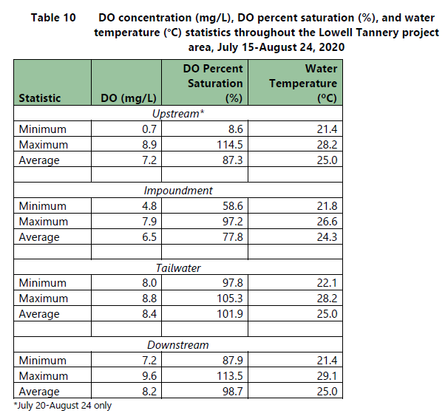
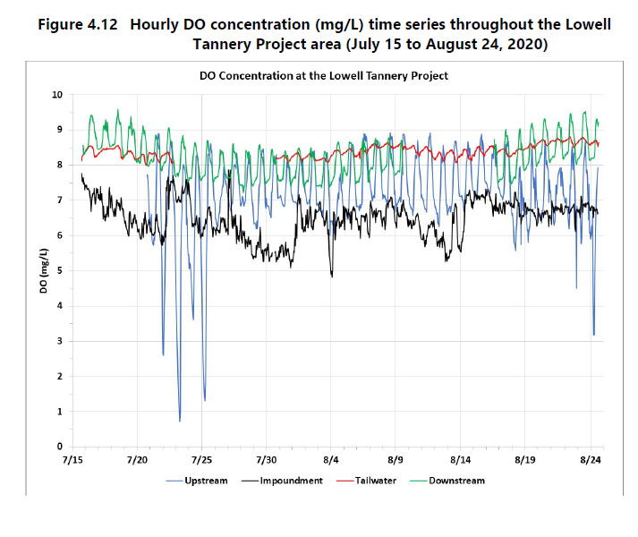
The 2020 monitoring showed that the Upstream site regularly had DO concentrations and percent saturation levels below the Class A/AA standards (Figure 4.12). The DO concentration and percent saturation at the deep spot in the impoundment were consistently between 6.0 mg/L and 7.5 mg/L and 60 percent to 90 percent, respectively. In the tailwater and downstream of the dam, the DO concentration and percent saturation were above the Class AA standards throughout the monitoring period.

Analysis of the sampling results indicates that Passadumkeag River above the project is frequently below Class A dissolved oxygen levels, which contributes to periodic low DO values in the impoundment and tailrace. The river’s natural conditions of high color and DOC are characteristic of this wetland-dominated, low gradient stream system and appear to be the primary contributors to low values measured within the project area.

Elevations are provided in feet above mean sea level.
The epilimnetic zone is determined by establishing a temperature profile at 1-meter increments to define the epilimnion as the upper layer where the change in temperature per meter of depth is less than 1 degree Celsius.
FLA document stated, “…samplers were installed at one (1) sample site approximately 490-feet downstream of the dam on August 9, 2019…”. However, the ISR and other project materials listed August 6, 2019 as the deployment date. The Department assumes that August 9th was an error.

