WATER QUALITY ASSESSMENT
MEMORANDUM

TO: Laura Paye, Hydropower Coordinator, Bureau of Land Resources

FROM: Wendy Garland, Director
Division of Environmental Assessment, Bureau of Water Quality

DATE: December 11, 2025

RE: Lewiston Falls Hydroelectric Project Water Quality Assessment

This Water Quality Assessment Memorandum (WQAM) provides a summary of the Bureau of Water Quality’s Division of Environmental Assessment staff review of the Lewiston Falls Hydroelectric Project (Project) Water Quality Certification (WQC) application. Additionally, staff provided a preliminary assessment of whether the Project attains applicable State water quality standards and staff recommendations for WQC conditions or mitigation measures.
This WQAM is advisory in nature and does not contain any Department findings or constitute a Department action related to the Project WQC application. The Department’s WQC Order, signed by the Commissioner, will represent the Department’s findings regarding the Project’s attainment of water quality standards and will include any applicable conditions.

Project Description
On July 9, 2025, the Applicant applied to the Department for WQC pursuant to Section 401 of the CWA for the proposed relicensing and continued operation of the existing Lewiston Falls Hydroelectric Project P-2302 (Lewiston Falls Project), located on the Androscoggin River in the Towns of Lewiston, Auburn, and Durham, Androscoggin County, Maine. The application was accepted for processing on July 9, 2025.

The Lewiston Falls Dam is located on the Androscoggin River at river mile 30.8. There are 22 hydroelectric project dams on the mainstem of the Androscoggin River. The Lewiston Falls Project is situated between the upstream Gulf Island-Deer Rips Project and the downstream Worumbo Project. The existing Project consists of a multi-section dam, a 169-acre impoundment, powerhouse containing two generating units with an authorized installed capacity of 28.44 megawatts (MW), a canal gatehouse that regulates water into the Lewiston Canal, an equipment building, 12.5-kilo Volt (kV) generator leads, a 12.5/34.5-kV, 30 MVA transformer, a short 34.5-Kv service-drop, and appurtenant facilities.
The dam is comprised of five sections with an elevation of 168.17 feet NGVD. The four stone masonry dams, referred to as Dam 1, Dam 2, Dam 3, and Dam 4, are integrated into ledge outcroppings and islands to form a continuous barrier across the river, with a maximum height of 23 feet. Dam 5 has a maximum height of 4 feet with a fixed crest elevation of 166.83 feet. This crest is fitted with steel pins that support the 1.34-foot-high flashboards. The Island Spillway is a concrete section abutted by bedrock and the left abutment of Dam 3.
Dam 1 extends 154 feet from the Auburn shore to a ledge outcrop in the river. Beyond the outcrop, Dam 2 stretches nearly 279 feet to a large island in the middle of the river. Dam 3 runs about 161 feet from the southern end of the island to the Island Spillway and Dam 5. Dam 4 extends about 279 feet to the northerly side of the Equipment Building on the Lewiston Shore. A single rubber dam is installed on each of Dam 1, Dam 2, and Dam 3. Two separate bladder sections are installed on Dam 4.
When the rubber dam sections are deflated, the crest of each spillway section is at an elevation of 164.17 feet. The crest of the rubber dams on Dams 1 and 2, when fully inflated, are at elevation 169.07 feet. The crest of the rubber dams for Dam 3 and Dam 4 are at elevation 168.6 feet. The inflatable rubber dams serve as crest gates and are designed to maintain the existing normal pond elevation of 168.17 feet. The rubber dams are designed to deflate when the headwater reaches approximately 20 percent overtopping at approximately 169.95 feet. Dam 5 is topped with 1.34-foot-high flashboards.
- The impoundment area extends upstream approximately 2.5 miles and covers an area of approximately 169 acres. The gross storage volume of the impoundment is approximately 2,102 acre-feet at the full pond elevation of 168.17 feet.
- The canal gatehouse is located about 550 feet to the southeast of Monty Station, which serves as the intake and flow regulating structure for the Lewiston Falls Canal System. The gatehouse measures about 112 feet long and 26 feet wide.
- The powerhouse (Monty Station) is located at the east end of the falls on the Lewiston side of the river. The powerhouse is a reinforced concrete structure, constructed in ledge that contains two vertical Kaplin generating units. Each turbine is rated at 18,000 horsepower (hp) under a 54-foot gross head and is capable of passing up to 3,000 cubic feet per second (cfs). Each of the turbines is directly coupled to a 15,800 kilovolt-ampere (kVA) synchronous generator, with a power factor of 0.90. The total installed capacity of both generators is 28.44 MW.
The powerhouse intake is a section of reinforced concrete measuring 85-feet-long, 2 inches-wide by approximately 40-feet-high. The intake opening is covered by trash racks that are 35-feet 9-inches high. The trash racks are constructed of 0.75 inch bar steel at 4 inches on its center, resulting in a clear spacing of 3.25 inches. The intake contains four intake tubes that are 16 feet 9.5 inches wide.
- The Monty Station tailrace is a deep channel excavated into rock ledge. The tailrace channel is approximately 400 feet long and 75 feet wide. Substrate in the tailrace is solid bedrock.
- There are currently no upstream or downstream fish passage facilities at the Lewiston Falls Project.

Generation at the Lewiston Falls Project is coordinated with Brookfield’s Gulf Island-Deer Rips Project located approximately five miles upstream of Lewiston Falls. Lewiston Falls is normally operated as run-of-river with impoundment fluctuations of one foot or less, daily. However, the Project is licensed to operate with up to four feet of impoundment fluctuation (between 168.17 feet and 164.17 feet) to allow for adjustments between inflow and minimum flow requirements, or to respond to operating emergencies or maintenance activities. The Lewiston Falls impoundment has no appreciable useable storage capacity.

The maximum hydraulic capacity of the Project’s generating units is 6,600 cfs and the minimum hydraulic capacity of a single unit is approximately 800 cfs. Flows in excess of the powerhouse capacity are spilled at the dam. The inflatable rubber bladders on Dams 1, 2, 3, and 4 serve as crest gates and are designed to maintain the existing normal pond elevation of 168.17 feet. The gates will automatically deflate when the headpond reaches approximately 20 percent overtopping of the rubber dam at an approximate elevation of 169.95 feet.
The Project is operated to provide a minimum flow of 1,430 cfs or inflow, whichever is less. The minimum flow for the Lewiston Canal System is 50 cfs. Any flows provided through the Canal System are considered part of the total 1,430 cfs required minimum flow. Additionally, under agreement with the City of Lewiston, BWPH provides periodic canal “refreshment flows” of 300 cfs (including the canal minimum flow) in accordance with a Stagnation Prevention Plan.

No new power development structures or generating facilities are proposed in the license application for the project. The Applicant proposes to remove a non-Project building from the boundary, that will remove 0.08 acres from the existing Project boundary. The Applicant proposes the following regarding operation, minimum flow, and impoundment levels:
- BWPH proposes to continue operating the Project as essentially run-of-river, with target impoundment fluctuations of one foot or less, on a daily basis, during the period of May 15 through June 30, but with the ability to operate with up to four feet of impoundment fluctuations during the rest of the year.
- BWPH proposes to maintain the current minimum flow of 1,430 cfs, or inflow, whichever is less, of which 50 cfs is through the Lewiston Canal System. For the purposes of providing aesthetic flows over the falls, BWPH proposes to provide approximately 2,000 to 2,500 cfs over the falls, from either Dam 1 or 3, six times each year during the months of July through September, between the hours of 10:00 AM and 4:00 PM.
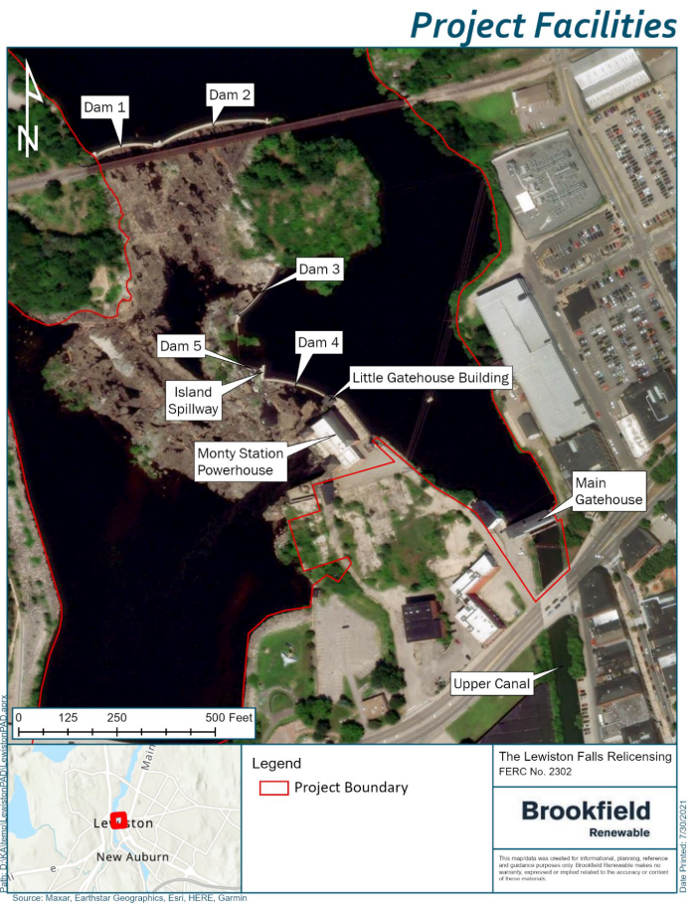
Project Boundary and Facilities
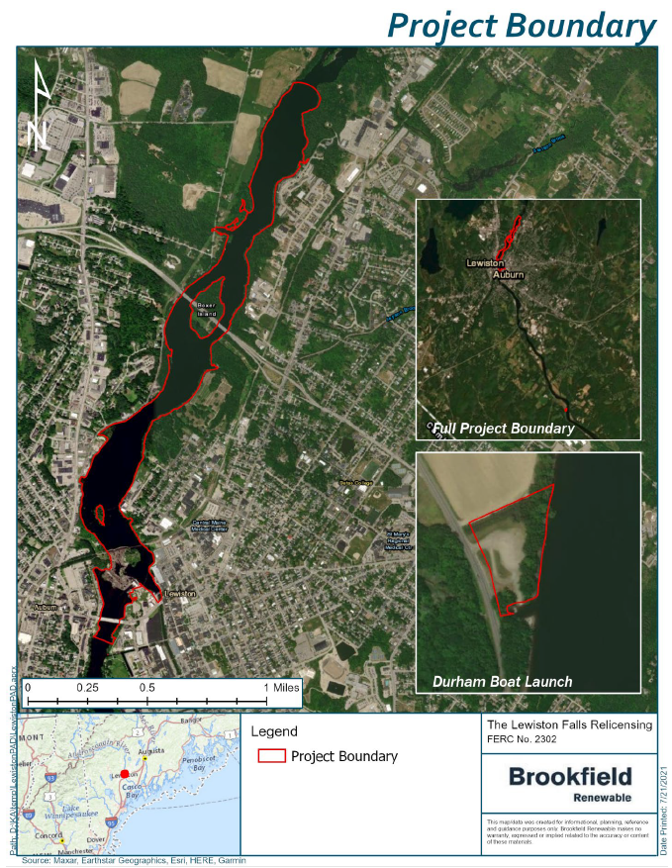

Applicable Standards
Water Quality Standards and the water quality classifications of all surface waters of Maine are established by the Maine Legislature (38 M.R.S. §464-469). The Androscoggin River, main stem, including all impoundments, from its confluence with the Ellis River to Worumbo Dam in Lisbon Falls is classified as Class C (38 M.R.S. §467(1)(A)(2)). This includes the project area.

Relevant water quality standards for Class C waters include the following:
- 38 M.R.S. §465 - Class C waters must be of such quality that they are suitable for the designated uses of drinking water supply after treatment ; fishing; agriculture; recreation in and on the water; industrial process and cooling water supply; hydroelectric power generation, except as prohibited under Title 12, section 403; navigation; and as habitat for fish and other aquatic life.
Class C waters must be of sufficient quality to support all species of fish indigenous to those waters and to maintain the structure and function of the resident biological community. The dissolved oxygen content of Class C water may not be less than 5 parts per million or 60% of saturation, whichever is higher, except that in identified salmonid spawning areas where water quality is sufficient to ensure spawning, egg incubation and survival of early life stages, that water quality sufficient for these purposes must be maintained.
In order to provide additional protection for the growth of indigenous fish, the following standards apply: The 30-day average dissolved oxygen criterion of a Class C water is 6.5 parts per million using a temperature of 22 degrees centigrade or the ambient temperature of the water body, whichever is less.
- 38 M.R.S. §464(13) - Compliance with dissolved oxygen criteria may not be measured within 0.5 meters of the bottom of existing riverine impoundments. Where mixing is inhibited due to thermal stratification in an existing riverine impoundment, compliance with numeric dissolved oxygen criteria may not be measured below the higher of:
(1) The point of thermal stratification when such stratification occurs; or

(2) The point proposed by the department as an alternative depth for a specific riverine impoundment based on all factors included in section 466, subsection 11‑A and for which a use attainability analysis is conducted if required by the United States Environmental Protection Agency.
For purposes of this paragraph, "thermal stratification" means a change of temperature of at least one degree Celsius per meter of depth, causing water below this point in an impoundment to become isolated and not mix with water above this point in the impoundment.
- Additional numeric standards for aquatic life as described in Chapter 579 Department rules, Classification Attainment Evaluation Using Biological Criteria for Rivers and Streams.
- Freshwater nutrient criteria as described in Chapter 583 Department rules, Nutrient Criteria for Class AA, A, B, and C Fresh Surface Waters, which was adopted June 11, 2025.

Water Quality Assessment
Division of Environmental Assessment (DEA) staff reviewed the WQC application and evaluated associated data to assess whether the Project meets applicable water quality standards. DEA staff assessments for each water quality standard are summarized below.
- Impoundment Aquatic Habitat
The Applicant must demonstrate that the Lewiston Falls Project impoundment is suitable for the designated use of habitat for fish and other aquatic life. Conformance with the aquatic habitat designated use is determined by methods described in the Department’s Hydropower Project Flow and Water Level Policy, dated February 4, 2002 (Water Level Policy). Under this policy guidance, the Department operates under the rebuttable presumption that a water level that provides wetted conditions for 3/4ths of the littoral zone of a lake or pond, as measured from full pond conditions, will be needed to meet aquatic life and habitat standards. On a case-by-case basis, the Department may approve alternative flows or water levels under circumstances defined in the Water Level Policy, where the alternative flows or water levels can be shown to meet all applicable water quality standards.

Following Maine Department of Environmental Protection (MDEP) protocol, the littoral zone was defined as the elevation range of 168.17 feet NGVD29 (licensed normal impoundment elevation) to 143.37 feet NGVD29 based on twice the mean summer Secchi disk depth obtained from the Impoundment Trophic State Study. The Applicant provided the volume, surface area, and percent of the littoral volume and surface area maintained for various impoundment elevations, including the normal full pool impoundment elevation (168.17 feet), the typical 1-foot operating range, the licensed 4-foot impoundment maximum level fluctuation elevation (164.17 feet), and the bottom of the littoral zone (143.37 feet).

According to the March 2023 Study Report, Appendix B, approximately 92.0% of the littoral zone volume is maintained at 1 ft below the normal full impoundment level. At 2 ft below the normal full impoundment level, approximately 84.1% of the littoral zone volume is maintained, and at 3 feet below the normal impoundment elevation, approximately 76.3% of the littoral volume is maintained. At 4 ft below the normal impoundment level, approximately 90.4% of the littoral surface area is maintained but only approximately 68.8% of the littoral volume is maintained, which is less than the 75% specified in the Water Level Policy.
The Applicant states that an analysis of hourly project operations data obtained from the Project’s SCADA system for 2017 through 2021 shows that an impoundment elevation of 164.17 (four feet below full pond) occurred only twice during that period and was for the purposes of Project maintenance and to maintain downstream minimum flows during a period of drought. If this level of drawdown is necessary for certain maintenance activities or severe drought conditions, those activities and conditions should be clarified in the license so that drawdowns resulting in a littoral volume less than 75% occur under very limited circumstances.

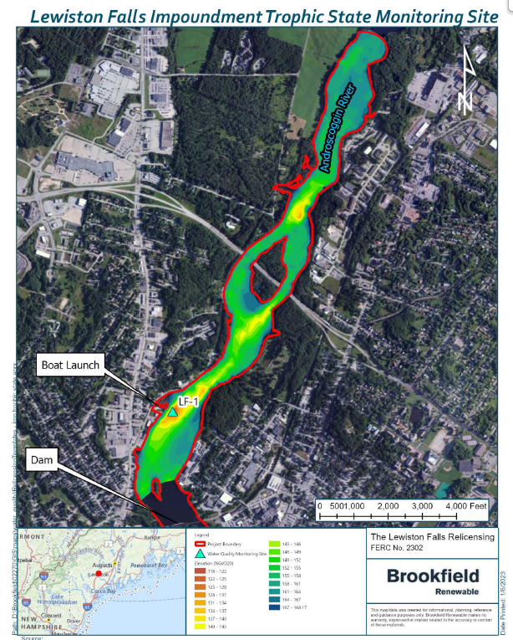
- Impoundment Trophic State
Impoundment trophic state data collection was performed twice per month at approximately 2-week intervals beginning May 31, 2022, through October 19, 2022, at the deepest location in the impoundment, which was identified by traversing the impoundment using a boat equipped with a sonar depth finder and found to be approximately 15 meters (49 feet) deep.
A vertical profile was collected at sampling location (LF-1) during each field visit. Dissolved oxygen (DO) and water temperature data were collected every meter from the surface to approximately 0.5 meters from the bottom. Water clarity was measured during each field visit using a Secchi disk and an Aquascope. Water samples were collected for laboratory analysis each visit from the epilimnion using a 10-m long integrated core sampler following MDEP’s Sampling Protocol for Hydropower Studies.
Water chemistry data is summarized in Table 3-4 (below). Total phosphorus (TP) in the impoundment ranged from 14 to 32 ug/l with a geomean of 18.9 ug/L, which is below the Chapter 583 Class C TP criteria of 44 μg/L. Chlorophyll-a ranged from 1 μg/l to 5 μg/L with a geomean of 2.45 μg/L, which is below the Ch. 583 Class C freshwater criteria (i.e., spatial geometric mean ≤ 8 μg/L and no values ≥ 10 μg/L). Color ranged from 4 PCU to 34 PCU with an average of 22.8 PCU. The Secchi disk depth (average of two daily readings) ranged from 1.14 meters to 4.34 meters with an average of 3.14 meters. Given moderate Chl and TP (both within the mesotrophic range), the relatively low transparency was largely due to sediment load rather than algal density.
Using the average chlorophyll-a concentration for the entire sampling period (3 μg/L), the TSI for the Lewiston Falls impoundment is 39.8, which is categorized as mesotrophic.
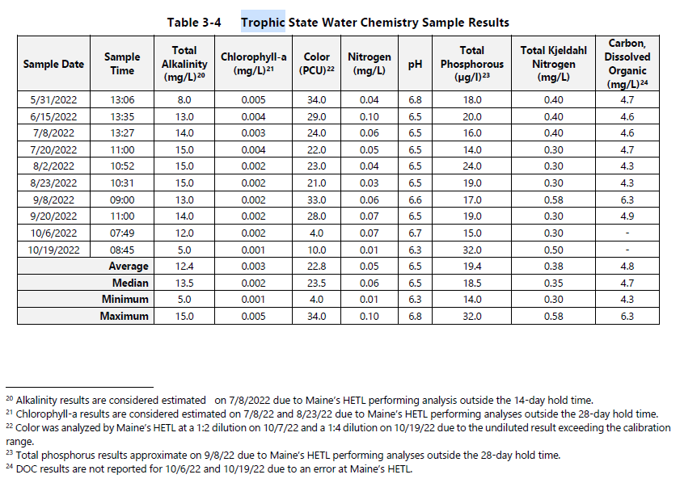

DO and temperature profiles indicate that the impoundment was stratified during one of the 10 sampling events (7/8/22). DO was above 5 mg/L and 60% saturation throughout the water column for all sampling events except two sampling events. On July 8, all low DO values were observed below the point of thermal stratification and on July 20, one low DO reading was observed within 0.5 meters of the bottom. As such, DO in the impoundment meets Class C standards.

Based on the sampling results and information contained in the WQC application, the Project impoundment meets applicable Class C water quality standards and is free of culturally induced algal blooms. Trophic data indicate that the impoundment is in the mesotrophic range.

- Downstream Aquatic Habitat
The Applicant conducted a downstream cross-sectional flow study consisting of 3 transects to document bankfull elevations, bed profiles and surface water elevations under key flow scenarios. The Applicant noted that the banks in the vicinity of the transects were highly modified however, including structures, riprap, parks, and bank excavation, therefore it was not possible to accurately determine bankfull elevations based on typical field indicators such as breaks in slope and changes in vegetation. Instead of calculating cross-sectional areas based on field-measured bankfull elevations, transect and water level data were used to compute average and maximum depth and wetted widths at the Project minimum flow. Wetted widths at minimum flow were then compared to bankfull wetted widths.

At the minimum project flow of 1,380 cfs, average depth, maximum depth and percent wetted bankfull width for the 3 downstream transects are summarized below:

 | Average Depth (feet) | Maximum Depth (feet) | % Wetted Bankfull Width
Transect 1 | 4.4 | 8.8 | 98.2
Transect 2 | 11.1 | 16.7 | 91.0
Transect 3 | 10.8 | 21.5 | 98.2

While the above figures do not technically demonstrate that 75% of the bankfull cross-sectional area is wetted at all times, the minimum Project flow of 1,380 cfs appears to provide adequate depth and wetted width to maintain a zone of passage and habitat for aquatic life. Results of macroinvertebrate sampling described in Section d below confirm that Class C aquatic life criteria were attained in 2022.

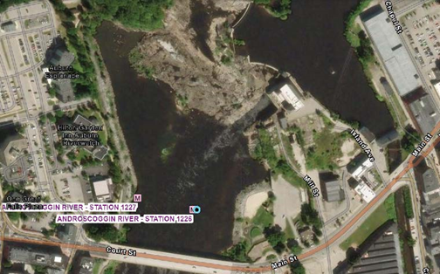
- Downstream Aquatic Life
The applicant completed benthic macroinvertebrate sampling in 2022 consistent with MDEP’s Methods for Biological Sampling and Analysis of Maine’s Rivers and Streams at two locations approximately 200 meters downstream of the powerhouse on river right and left. Rock baskets were deployed on July 13 and retrieved 28 days later on August 10. DEP staff analyzed resulting data using its linear discriminant model and found that the macroinvertebrate community at both sites met aquatic life criteria for Class C. Therefore, the macroinvertebrate community at these sites attains applicable aquatic life criteria.

- Downstream Dissolved Oxygen and Temperature
The Applicant conducted a continuous Dissolved Oxygen and Temperature Study at a location downstream of the Project at LF-2 (below the tailwater) from July 7, 2022 to September 8, 2022. Hourly measurements were collected approximately mid-depth. Flow in the Androscoggin River was below the long-term median for most of this period.
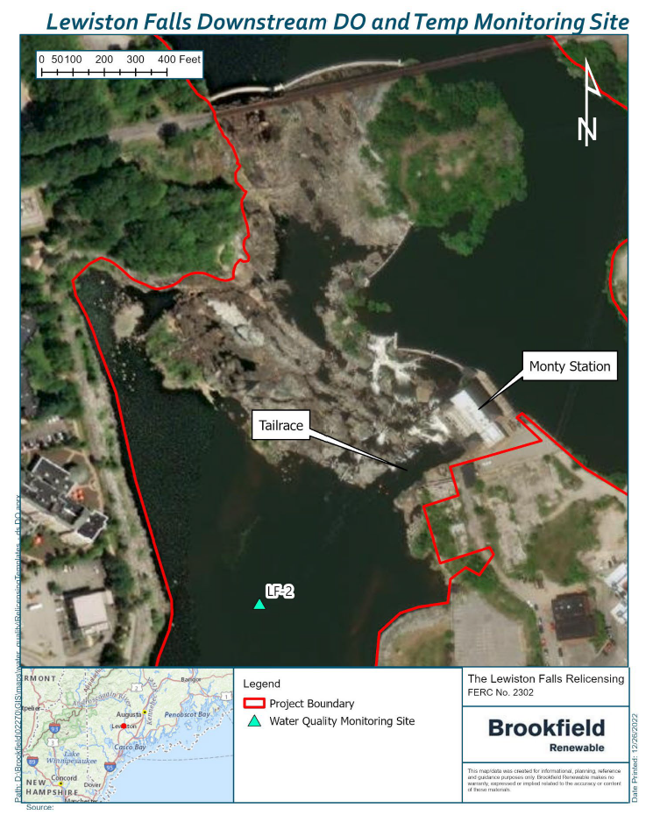
Data over the full sampling period ranged from 4.82 to 8.57 mg/L, with an average of 7.54 mg/L. Values in July ranged from 6.87 to 8.57 mg/L, with an average of 7.71 mg/L. Values in August ranged from 4.82 to 8.2 mg/L, with an average of 7.33 mg/L. Although water temperature was never colder than 22 degrees centigrade, DO never fell below 7.1 mg/L as a 30-day average at LF-2 for
both July and August, which was above the MDEP Class C standard of 6.5 mg/L.

DO was above the MDEP Class C standard of 5 mg/L or 60% saturation for the entire study period except for only one hourly point that occurred on August 21 at 02:00 when DO concentration dropped to 4.82 mg/L. The single hourly point was part of a longer drop in DO that occurred from August 20 at 06:00
to August 21 at 05:00 (Figure 3-11). DO during this time did not exhibit the typical patterns seen throughout the rest of the study period. Immediately before and after this event, DO concentrations were above or near 7 mg/L. There were no changes to Project operations during this time, with Unit 1 offline, Unit 2 producing a steady output, and minimal spillage due to leakage. Additionally, vertical profiles measured in the Project impoundment both before and after the low DO event (August 2 and August 23) indicated that DO was above 5 mg/L throughout the water column. Finally, the field spot check conducted on August 23 at LF-2 was within 0.3 mg/L of the continuous loggers reading prior to removal and cleaning, indicating that biofouling was not responsible for the low DO value. Therefore, this lower DO event would not have been caused by operations at the Lewiston Falls Project. and may be associated with a 1.1-inch rainfall event on August 17-August 18 in the Lewiston-Auburn area. Additional continuous monitoring would be needed to better understand the causes associated with these outlier data.

Based on the sampling results in the Downstream DO and Temperature Study, the Project meets applicable Class C DO standards.
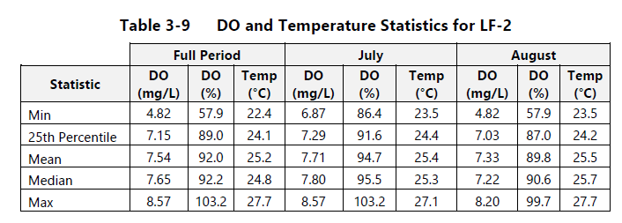
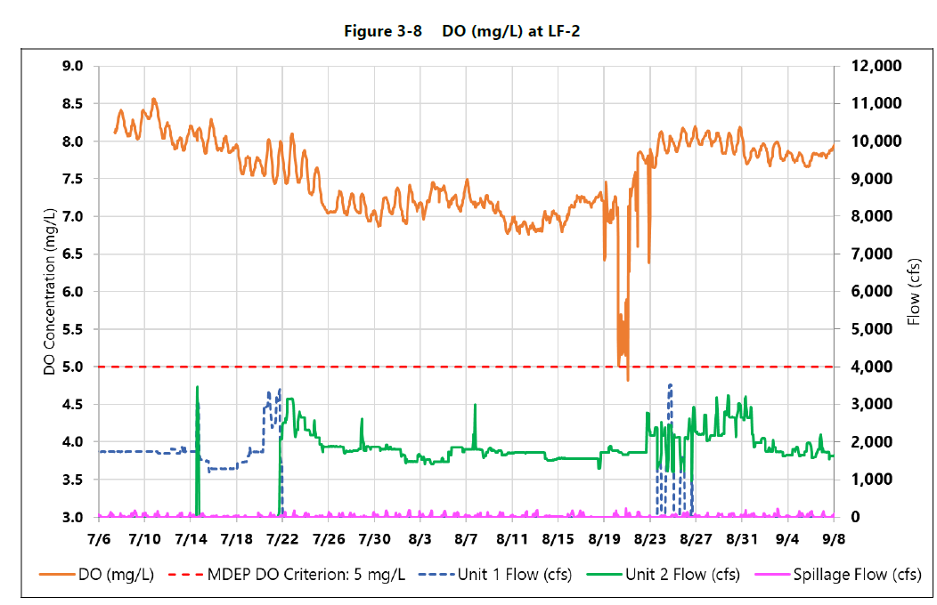
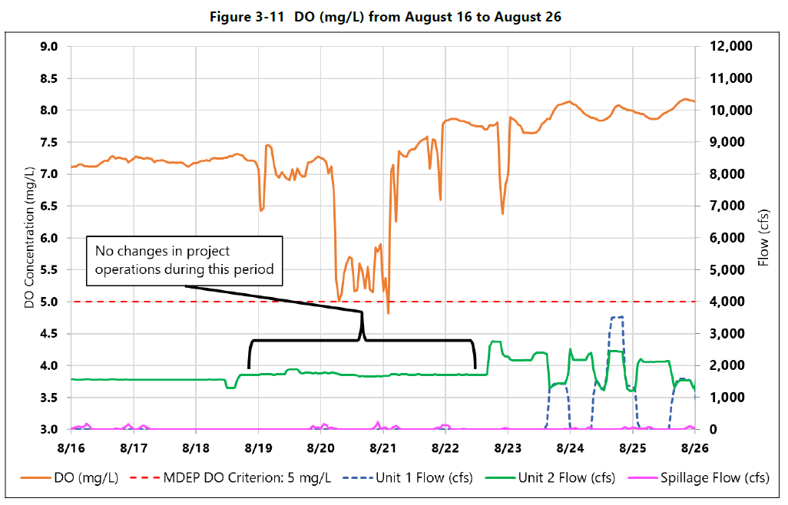
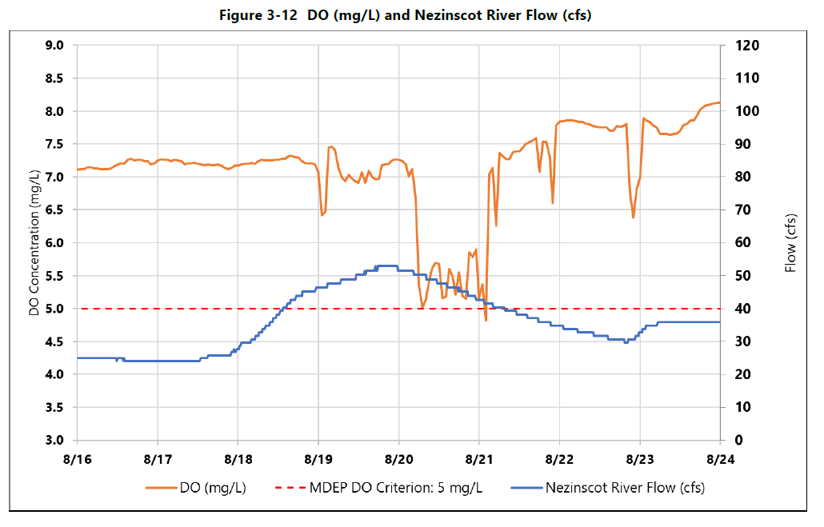

All elevations are in National Geodetic Vertical Datum (NVGD) of 1929, unless otherwise specifically noted.
The Final License Application is expressly incorporated into the WQC application, as supplemented by BWPH.
Final adopted TP criteria for Class C waters is 44 ug/L, not 40 ug/L as listed in the draft study report. The TP criterion is the geometric mean in a season, and the Chlorophyll a criterion is the spatial geometric mean, which means geometric mean of multiple measurements of chlorophyll a that were collected at different locations in an impoundment. This calculation may include data collected at different times during a season. In the Lewiston Falls study, Chl a was only measured at one location, and the analysis above is the seasonal geomean for that location.

