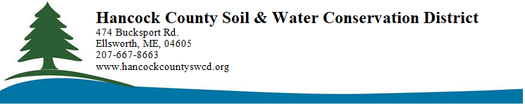

August 11, 2025

To: Laura Paye, DEP Hydropower Licensing
My name is Mark Whiting. I am a resident of Ellsworth, a founding member of the Friends of Graham Lake, and currently serve as Chair of the Board of Supervisors for the Hancock County Soil and Water Conservation District. Our mission is to preserve and protect the soil and water resources of Hancock County.
From the outset of Brookfield’s licensing process in 2015, the major environmental challenges on the Union River have been clear:
- High turbidity (“dirty water”) in Graham Lake and downstream;
- Extreme water level fluctuations in Graham Lake;
- Poor water quality in Leonard Lake (especially low dissolved oxygen and turbidity);
- Inadequate fish passage at the dams.

Turbidity and Water Quality
Clean water is one of the most fundamental responsibilities of any environmental agency.
Maine’s narrative water quality standards call for rivers to be “clean” and “clear of
settleable solids.” However, in the absence of a numerical turbidity standard, enforcement becomes ambiguous. DEP must develop enforceable turbidity criteria to meet both public expectations and the Clean Water Act’s intent.
I personally conducted two turbidity studies for Graham Lake and the Union River, which demonstrated that turbidity spikes are directly associated with extreme lake drawdowns. I recommended minimizing water level fluctuations to reduce sediment resuspension.
Brookfield’s current proposal for reduced drawdowns is a positive step that should
significantly reduce turbidity. However, DEP must be prepared to take further action if these improvements do not materialize.
Regarding Leonard Lake, persistent low oxygen levels at depth, along with occasional nutrient releases from anoxic sediments, remain a concern. During my tenure as a DEP
biologist, I investigated a bloom in the Union River near Leonard’s Lake, which was caused by blue-green algae and the dinoflagellate Ceratium hirundinella—indicative of degraded

water quality. DEP must ensure water quality improvements here as part of the
certification.

Fish Passage and Biological Standards
Perhaps the most difficult issue before DEP is fish passage. Under Maine’s water
classification system, a river with hydropower may get a Water Quality Certification by
meeting Class C requirements. This class still requires that the water body support “all indigenous species” of fish. According to the 2015 Draft Comprehensive Fisheries Management Plan for the Union River drainage, the native species list includes at least:
- Migratory fish: American shad, Atlantic sturgeon, river herring (alewife, blueback herring), rainbow smelt, striped bass, sea lamprey, American eel, Atlantic tomcod, and endangered Atlantic salmon;
- Resident sportfish: brook trout, landlocked salmon, lake trout, brown trout, arctic char (blueback), smallmouth and largemouth bass, and others.
The decline of migratory species is directly tied to dam construction. The 2015 report attributes their disappearance to 18th and 19th century dam building, which blocked access to critical spawning habitats.
The Union River is not expendable. It accounts for an estimated 6–10% of Maine’s annual elver harvest—a fishery worth ~$2 million, comparable in value to the electricity generated by the Ellsworth dam. The alewife run may be worth another $250,000. These are
significant economic and ecological values. Brookfield’s proposal must provide for safe, effective, and timely passage for all native migratory species, both upstream and
downstream. At present, this requirement is clearly unmet.
Brookfield has provided some accommodation for alewife and Atlantic salmon, and a few American eels manage to ascend, but there is no comprehensive strategy for passage of all species. DEP must demand one.

Scientific and Legal Context
Research consistently shows the detrimental effects of dams on river ecosystems and migratory fish. Zydlewski et al. (2023) summarize these challenges well in “Seven Dam Challenges for Migratory Fish” (Table 1). One stark image (Figure 1) shows dead juvenile alewives below the Ellsworth dam, victims of turbine blade strikes and decompression.

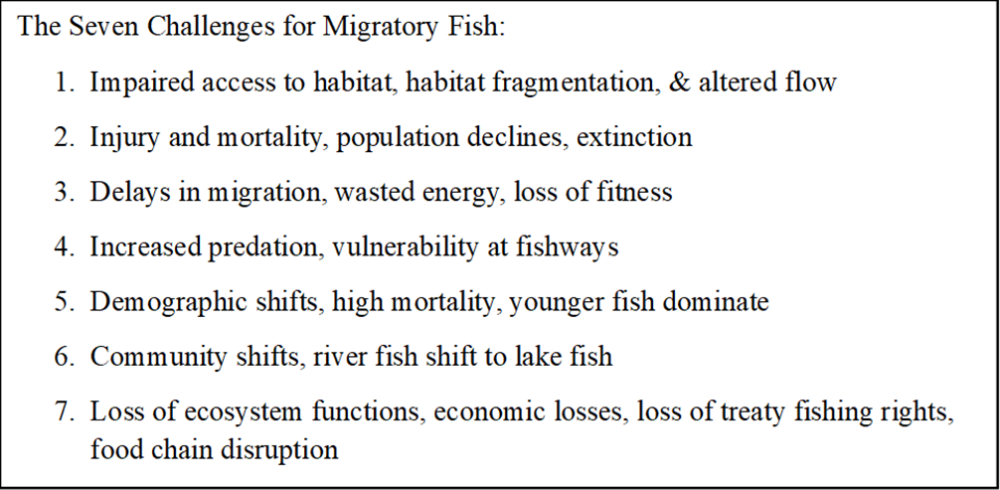

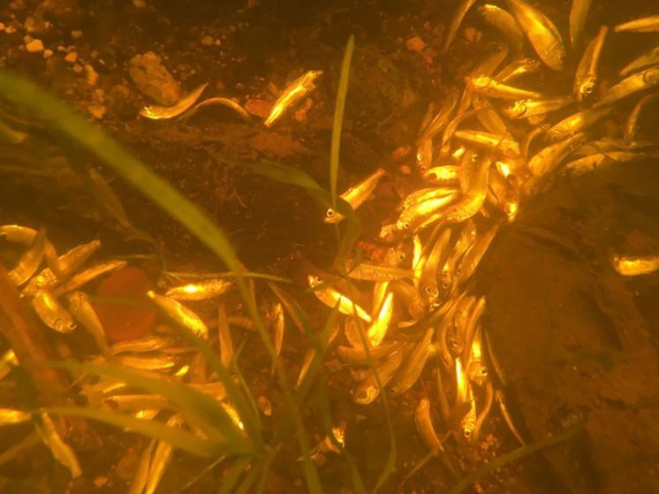

Successful precedents exist. The Penobscot River Restoration Project showed that meaningful fish recovery is possible when agencies, tribes, communities, and stakeholders work together. The Union River has similarly high potential. For example, the 2009 Atlantic States Marine Fisheries Commission report estimates the Union could support a river herring run of over 2 million ﬁsh annually (Figure 2) - twice the current number.

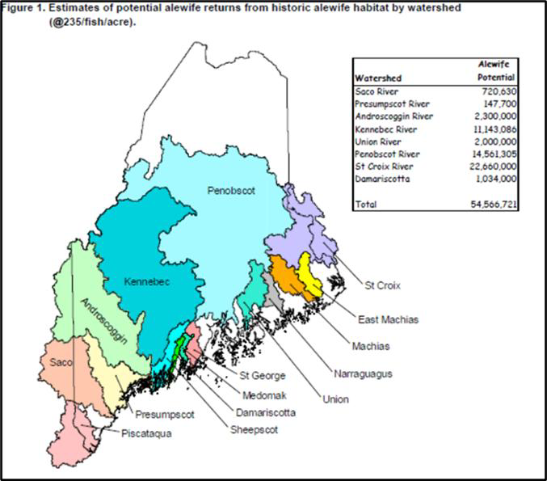
Figures 3–5 (from Hall et al., 2011 and Maine DIFW’s Stream Habitat Viewer) document the cumulative damage from dams and other barriers across Maine. These data reinforce that meaningful river restoration in Maine will require dam removals and strategic barrier mitigation.

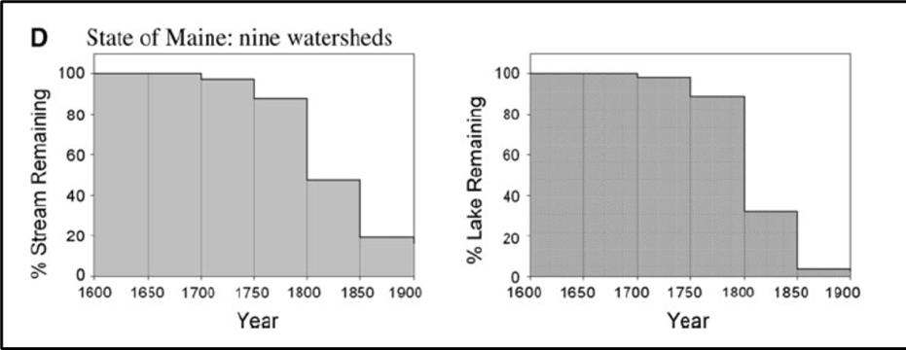
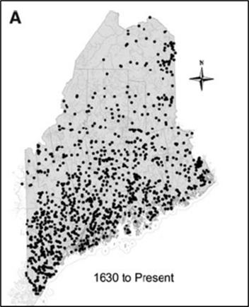

From Hall et al. 2011, Map of Dams in Maine and histogram showing the decline of free ﬂowing rivers and streams in Maine.

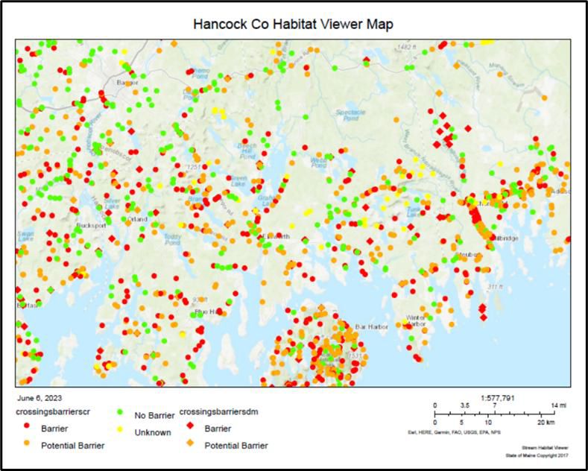

The Biodiversity Crisis and the Union River
Globally, freshwater biodiversity is in steep decline—far faster than in marine or terrestrial ecosystems. One-third of all freshwater species are at risk of extinction, according to the IUCN Red List. Habitat loss (especially dams), pollution, and climate change are among the top drivers. DEP has both a legal and ethical obligation to take this context seriously.
In Maine, multiple freshwater species—including several fish and mussels—are at risk. Table 2 summarizes this data from the Maine DIFW's "Comprehensive Wildlife Conservation Strategy". These species depend on restored river connectivity.

Species | Status - Level of Concern | Listing Agency
 | (rank 1-3)
Alewife | 2 | DIFW
Blueback Herring | 1 | DIFW
Shad | 1 | DIFW
Atlantic Salmon | Endangered | USFWS
Brook Trout | 3 | DIFW
Sea-run Brook Trout | Special Concern | DIFW
Arctic char | Special Concern | DIFW
American Eel | Special Concern | DIFW
Rainbow Smelt | 1 | DIFW
Shortnose Sturgeon | Endangered | USFWS
Atlantic Sturgeon | Threatened | USFWS
Brook Stickleback | Special Concern | DIFW
Striped Bass | 2 | DIFW
Maine’s water quality laws, the Endangered Species Act, and Indigenous fishing rights under federal law all mandate effective restoration, not just status quo management.

Conclusion and Recommendations
DEP’s 401 Water Quality Certification review must address:
- Turbidity control: Adopt a numeric standard and monitor compliance;
- Leonard Lake's water quality: Improve oxygenation and reduce nutrient releases;
- Fish passage: Require safe, effective, and species-inclusive upstream and downstream passage;
- Compliance with Class C standards: Brookfield must show the river can support all indigenous species;
- Enforceable, measurable outcomes: Vague commitments are not enough.
The Union River is too important for half-measures. It is a vital ecological and economic resource, and a key opportunity for meaningful restoration in Maine. Let’s begin with real, measurable fish passage at the Ellsworth dam.

Sincerely,

Mark Whiting, PhD
Chair, Hancock County Soil & Water Conservation District Resident of Ellsworth, Maine

