water quality study
Impoundment and riverine sampling 2013

ELLSWORTH HYDROELECTRIC PROJECT
FERC No. 2727

Submitted by:
Black Bear Hydro Partners, LLC
Davenport Street
PO Box 276
Milford, ME 04461

Prepared by:
TRC
14 Gabriel Drive
Augusta, Maine 04330

JANUARY 2014

Table of Contents
1.0 Introduction 1-1
1.1 Project Description and Operation 1-1
1.2 Maine Water Quality Standards 1-1
2.0 Water Quality Sampling Methodology 2-1
2.1 Sampling Protocol 2-1
2.2 Sampling Locations 2-1
3.0 Results 3-1
3.1 Thermal Stratification 3-1
3.1.1 Graham Lake 3-1
3.1.2 Lake Leonard 3-1
3.2 Physical/Chemical Parameters 3-1
3.2.1 Graham Lake 3-1
3.2.1.1 Sample Station #3 (North) 3-1
3.2.1.2 Sample Station #1 (Central) 3-2
3.2.1.3 Sample Station #2 (South) 3-2
3.2.2 Lake Leonard 3-2
3.2.3 Union River 3-2
3.2.3.1 A.M. Sampling 3-2
3.2.3.2 P.M. Sampling 3-2
4.0 Conclusions 4-1

TABLES
Table 1-1: Maine Water Quality Standards for Select Parameters for Class B and GPA Waters 1-2
Table 2-1: Sampling Dates 2013 2-4
APPENDICES
Appendix A: MDEP’s Lake Trophic State Sampling Protocol for Hydropower Studies and River Sampling Protocol
Appendix B: Lake Level Elevations and River Flow Data
Appendix C: Dissolved Oxygen/Temperature Profile, Secchi Disk Transparency Data and Graphs
Appendix D: Other Sampling Parameter Data

Introduction
The Ellsworth Hydroelectric Project (Project) in Ellsworth, Maine consists of a lower dam, (Ellsworth Dam) with a small reservoir (Lake Leonard, Midas # 9663), and an upper dam (Graham Lake Dam) with a large storage reservoir (Graham Lake, Midas # 4350) and an intervening 3 mile stretch of the Union River.
Black Bear Hydro Partners, LLC (BBHP) initiated the integrated licensing process for the Project with the Federal Energy Regulatory Commission (FERC) in October, 2012. As part of that process BBHP filed a Proposed Water Quality Study Plan in April 2013 to conduct water quality sampling in Graham Lake, Lake Leonard, and the Union River. Following consultation with the Maine Department of Environmental Protection (MDEP), BBHP filed a Revised Water Quality Study Plan in August, 2013 which was subsequently approved by FERC in its September, 2013 Study Plan Determination. The study, which is based on the MDEP river and lake trophic state sampling protocols for hydropower studies, was conducted in accordance with FERC’s Study Plan Determination.

1.1 Project Description and Operation
The Ellsworth Dam is a 65-foot high, 377-foot long concrete structure. The Ellsworth powerhouse is integral with the dam. The powerhouse contains four generating units with a total capacity of 8.9 MW. Lake Leonard has a surface area of approximately 90 acres at normal maximum pool elevation, a width of 0.3 miles and a length of approximately 1.25 miles. The Ellsworth Dam is located at the upper limit of tidal influence on the Union River.
Graham Lake Dam is located approximately 3 miles upstream of Lake Leonard and consists of a 25-foot high, 550-foot long earthen dam with a concrete gate structure. Graham Lake has a surface area of approximately 9,024 acres, a width of up to 2 miles and a length of approximately 10 miles.
Operationally water releases at the Ellsworth Dam (including generation at the powerhouse) are run-of-river, utilizing water released from Graham Lake reservoir.

1.2 Maine Water Quality Standards
Maine water quality standards (38 MRSA §464-470) establish the basis for the State’s classification system of surface waters. The State has one water quality standard for lakes and great ponds (GPA) which includes natural water bodies greater than 10 acres and inland bodies of water artificially formed or increased that have a surface area greater than 30 acres. Graham Lake is included in this classification, however Lake Leonard is not. Designated uses for Class GPA water include: drinking water supply after disinfection; recreation in and on the water; fishing; agriculture, industrial process and cooling water supply; hydroelectric power generation; navigation; and habitat for fish and aquatic life. The habitat must be characterized as natural (Maine Revised Statute, 2012c).
There are four standards for the classification of fresh surface waters which are not classified as great ponds: Class AA, A, B, and C waters. The Union River from the outlet of Graham Lake to tidewater is classified as Class B (Maine Revised Statute, 2012a). By this definition, Lake Leonard is a Class B water body. Designated uses for Class B waters are the same as those for Class GPA waters an (described above), except in outstanding river segments (as defined under Title 12, section 403) where hydroelectric power generation is prohibited. The Union River is not designated as an outstanding river segment. The habitat in Class B waters must be characterized as unimpaired (Maine Revised Statute, 2012b).
The water quality standards for GPA and Class B waters are presented in Table 1-1 below.
Table 1-1: Maine Water Quality Standards
for Select Parameters for Class B and GPA Waters
Parameter | Standard Class B | Standard GPA
DO (mg/L) | 7 ppm or 75% of saturation, whichever is higher, except from Oct. 1st to May 14th, the 7-day mean DO concentration may not be less than 9.5 ppm and the 1-day minimum DO concentration may not be less than 8.0 ppm in identified fish spawning areas | No Numeric Standard
pH (su) | 6.0 to 8.5 | 6.0 to 8.5
E. coli | Between May 15th and Sept, 30th, not to exceed a geometric mean of 64 per 100 milliliters or an instantaneous level of 236 per 100 milliliters | Not to exceed a geometric mean of 29 per 100 mL or an instantaneous level of 194 per 100 mL
Aquatic Life Habitat | Unimpaired | Natural
Sources: Maine Revised Statute, 2012b and 2012c

Water Quality Sampling Methodology

2.1 Sampling Protocol
Water quality sampling for Lake Leonard and Graham Lake, and the Union River was conducted in accordance with the Maine Department of Environmental Protection’s Lake Trophic State Sampling Protocol for Hydropower Studies and River Sampling Protocols (Appendix A) respectively as per FERC’s Study Plan Determination. Specific sampling methods included: bi-monthly dissolved oxygen (DO) and temperature profiles, Secchi disk transparency, total phosphorus, chlorophyll a (Chla), color, pH, total alkalinity and turbidity for five consecutive months in Lake Leonard and Graham Lake. In addition, on one occasion for each lake in late August when the lakes were thermally stratified, additional parameters as delineated in the MDEP lake sampling protocol were sampled at three depths (epilimnion, and top and bottom of the hypolimnion). Furthermore, at the request of Green Lake National Fish Hatchery staff (June 13, 2013 e-mail) soluble reactive phosphorus (SRP) was added to the monitoring plan for the remainder of the sampling season per their consultation with DEP.
Sampling of the Union River consisted of DO-temperature profiles one day per week for 11 weeks during the likely summer low flow, high temperature period. Secchi disk and Chla samples were also taken each sampling day in the river. In consultation with MDEP, the “frequency and timing” sampling protocol in the river was adjusted for this project from 2pm to 1pm for the daily afternoon run.
Parameters requiring laboratory analysis were taken to the University of Maine Sawyer Environmental Chemistry Research Laboratory in Orono, Maine for analysis.

2.2 Sampling Locations
Sampling was conducted at three locations on Graham Lake. Station #3 was the northern basin, Station #1 was the central basin and Station #2 was the southern basin. These stations were previously documented and determined as deep holes by DEP where sampling has historically taken place.
Lake Leonard sampling was conducted at one mid-channel location, slightly north of the buoy barriers at the Ellsworth Dam. The sampling location is the deep hole in the impoundment.
Sampling in the Union River was conducted at one location as well. This sampling location was mid-channel, approximately 450 feet downstream from the Graham Lake Dam in accordance with MDEP protocol.
Each week GPS units were used to locate each sampling station. This allowed staff to anchor the boat very close to the same spot each week, resulting in consistency of sampling.
Ortho-photo based maps of Graham Lake and Lake Leonard, below show sampling station locations for each water body.
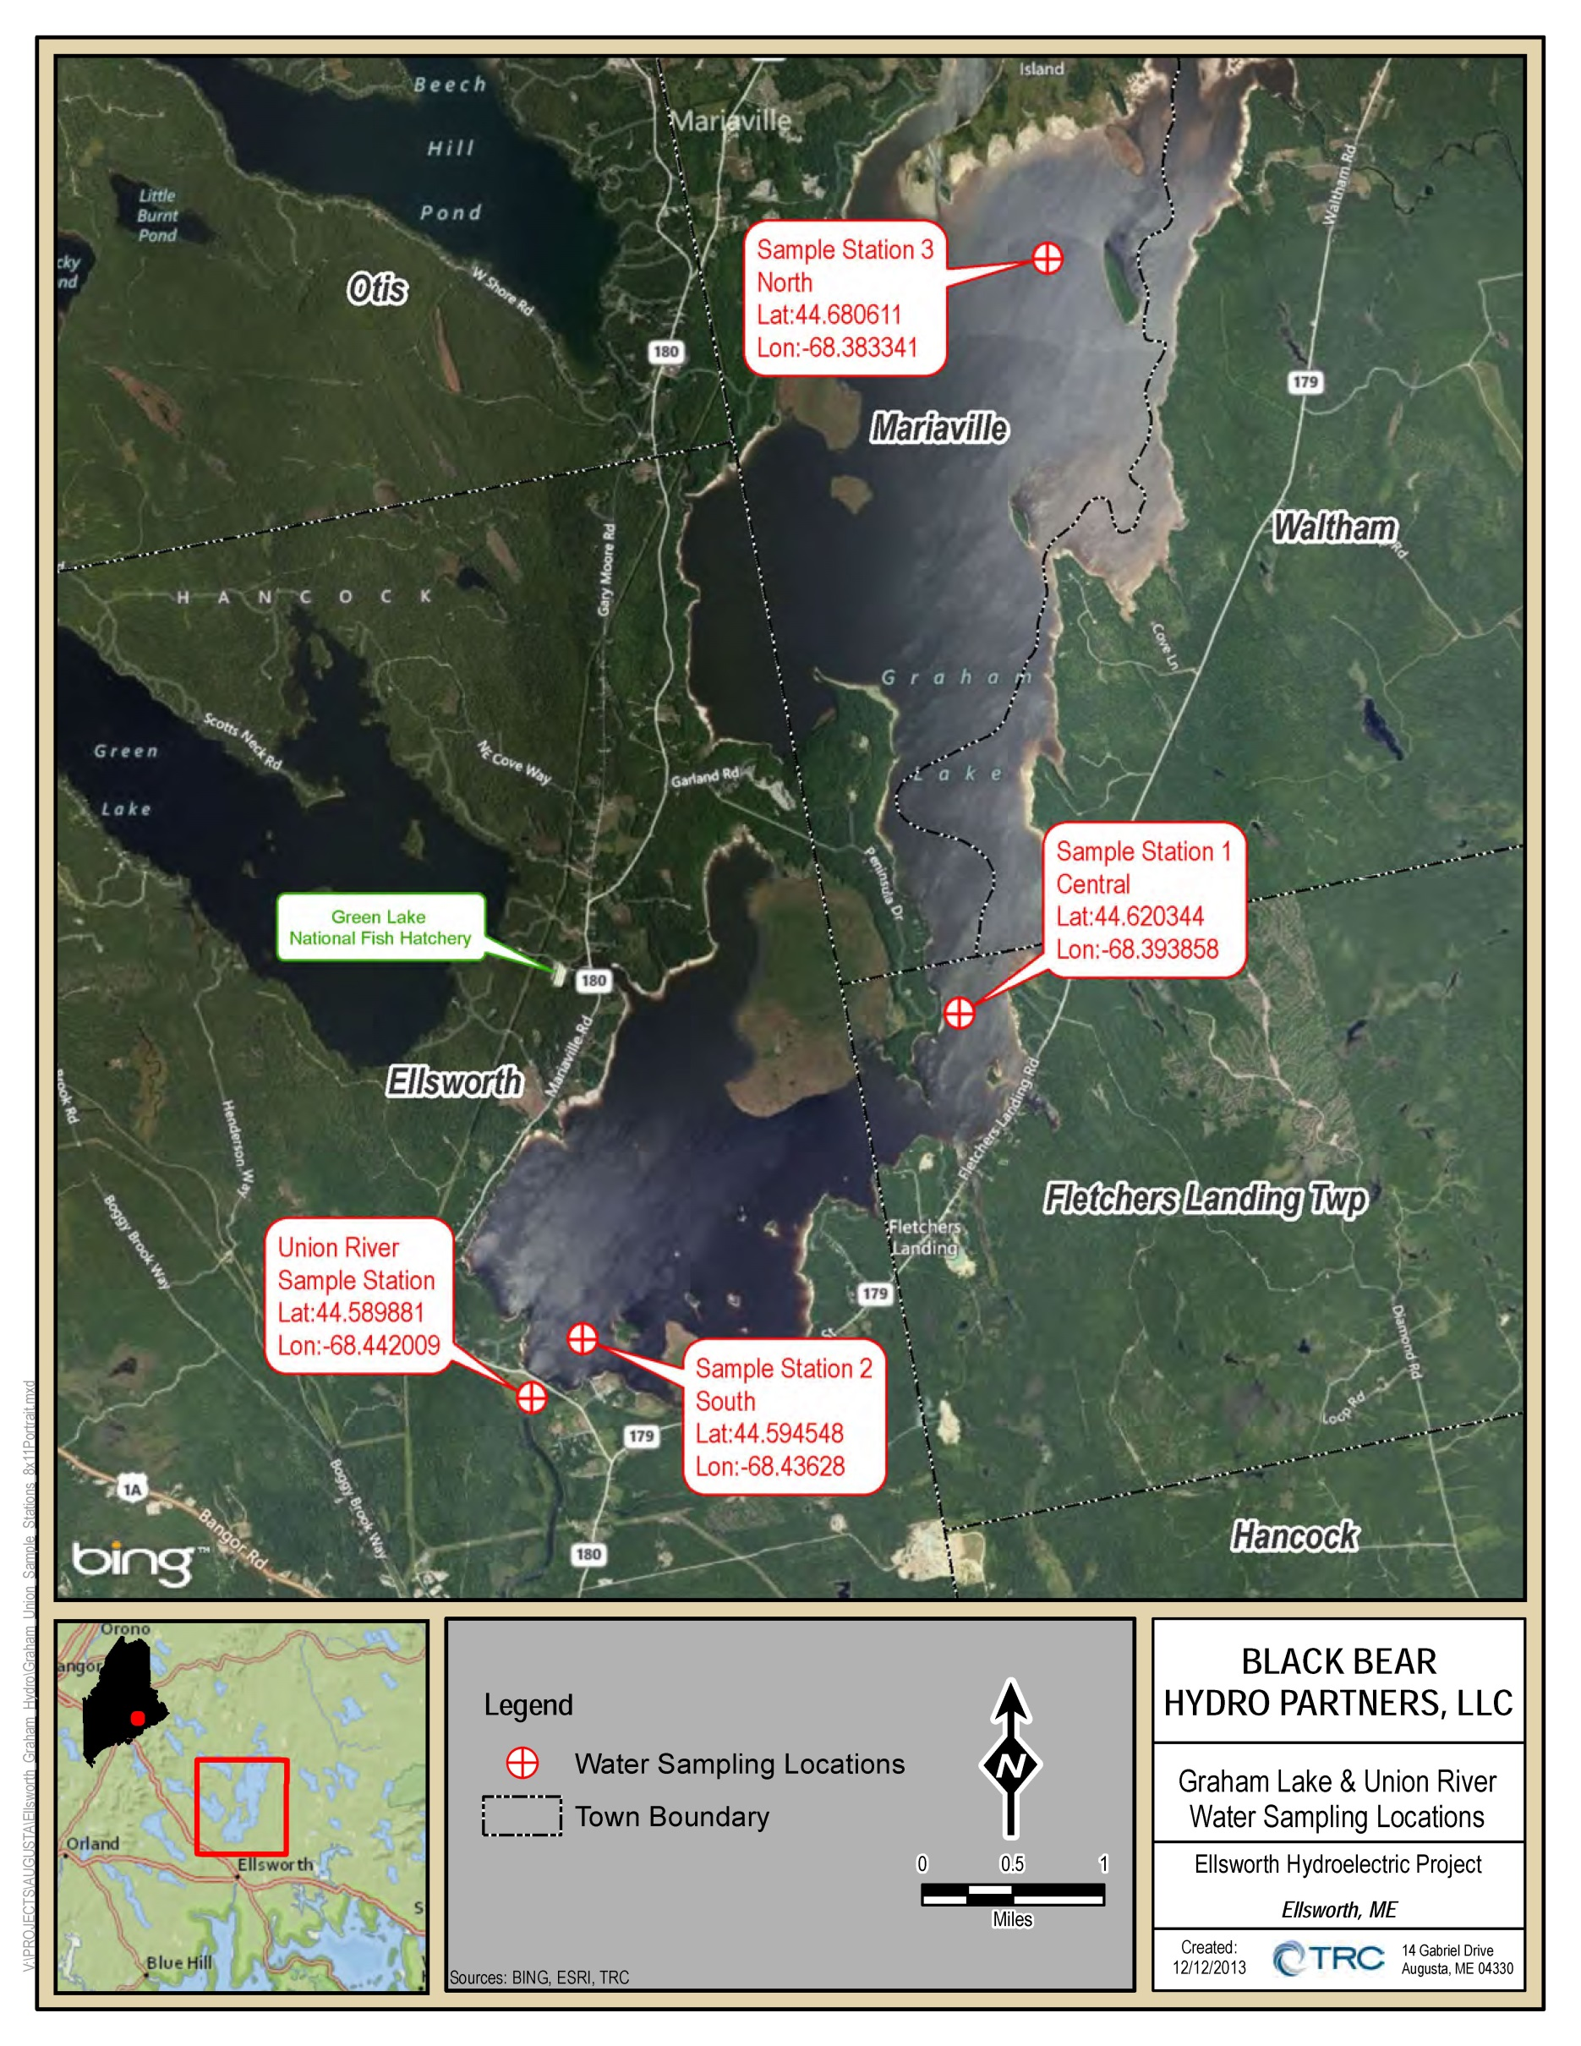
Figure 2-1 placeholde r Graham Lake Map
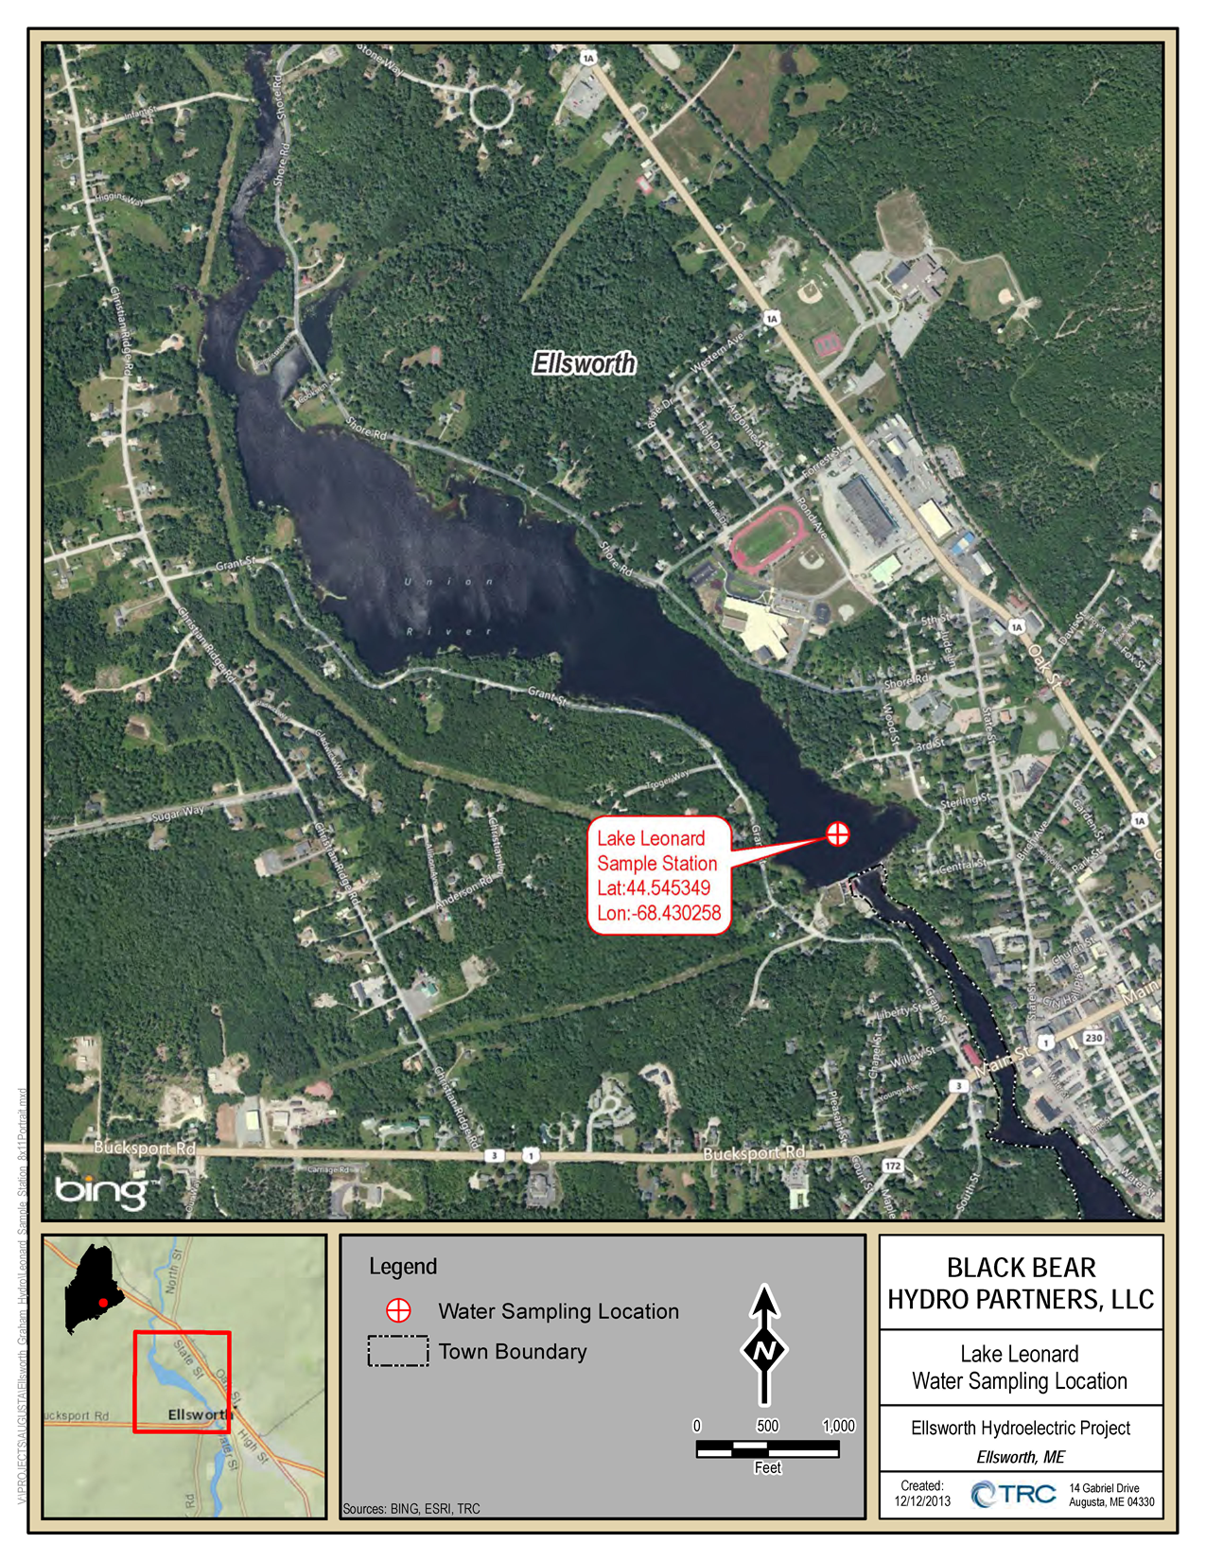
Figure 2-2 placeholder Lake Leonard map
2.3 Sampling Equipment
The DO and temperature measurements were collected with a portable hand held YSI 550A DO and temperature meter equipped with 50-meter cable. The meter was calibrated daily at each sampling station according to the applicable instructions provided by the meter manufacturer. Epilimnetic core samples were obtained using 3/4” tygon tubing, while discrete depth samples were taken using a Van Dorn bottle. Transparency in the water column was determined by using a weighted black and white Secchi disk with surveyor-grade metered tape, observed through an Aqua-Scope.
2.4 Data Collection
Water quality sampling occurred on twenty days during the summer of 2013 (Table 2-1). At the suggestion of MDEP, Green Lake National Fish Hatchery and BBHP agreed to coordinate in the collection of lake data for the 2013 sampling season. On April 23, May 15 and May 28 sampling was conducted by Green Lake National Fish Hatchery staff at Graham Lake. TRC accompanied hatchery staff on May 28 and conducted all sampling for the remainder of the 2013 sampling period alternating between Graham Lake and Lake Leonard on a bi-weekly basis. The Union River sampling was conducted by TRC for eleven consecutive weeks (July 2 through September 12) when the combination of low flow-high temperature conditions were most likely to be achieved. The MDEP river sampling protocol calls for five sampling days where the product of water temperature and flow duration exceeds 1500 as a measure of low flow-high temperature conditions. The Union River sampling exceeded the 1500 threshold on 3 of the 11 sampling days (Appendix B).
Table 2-1: Sampling Dates 2013
Date Sampled | Lake Leonard | Graham Lake | Union River
April 23 * |  | X
May 15 * |  | X
May 28 * |  | X
June 13 | X | X
June 27 | X | X
July 2 |  | X | X
July 11 | X |  | X
July 18 |  | X | X
July 25 | X |  | X
August 1 |  | X | X
August 8 | X |  | X
August 15 |  | X | X
August 22 | X |  | X
August 28 |  | X | X
September 5 | X |  | X
September 12 |  | X | X
September 19 | X
September 26 |  | X
October 3 | X
October 10 |  | X
October 17 | X
October 24 |  | X
*Green Lake National Fish Hatchery Sampling Dates
Only personnel MDEP-certified or experienced in measurement and data recording techniques participated in the data collection. All field data and observations were recorded in a field notebook or field data sheets and then later processed into Excel tables back in the office.
For all vertical profiles, measurements began at the water surface and continued down in 1-meter intervals, with a final reading taken approximately 1 meter from the bottom. The following steps were performed at each sampling location:
- Ensure that the meter has been calibrated and that appropriate quality control procedures have been followed.
- Place the senor into the waterbody at the desired sampling depth.
- Allow at least 30 seconds for temperature equilibrium record the temperature.
- On the field data sheet, record the DO and temperature (ºC). The reading should stabilize within ±0.2 mg/l.
- Return the sensor to the storage chamber.
Fluctuating water levels throughout the 2013 summer influenced the depth of profile during the sampling period, Graham Lake’s elevation varied from week to week, ranging from el. 104.2’ on the first sampling day to el. 98.17’ by the last sampling day; a change of over 6 feet. On the other hand, Lake Leonard’s elevations stayed consistent at el. 66.7’ throughout the entire summer.
Graham Lake sampling stations were accessed by motor boat which was launched from the Graham Lake boat launch by the Graham Lake Dam. Lake Leonard sampling was done out of a canoe launched from a carry-in site north of the substation area near the Ellsworth Dam. A canoe was also used in the tailrace of Graham Lake Dam to obtain samples in the Union River.
Lake elevations and river flow at the time of sampling are depicted in Appendix B.

Results
Results of lake and river sampling during the 2013 summer conditions are summarized for each sampling station, below. Complete results for DO, temperature and Secchi disk transparency are presented in graphic and tabular form in Appendix C. Chla, total phosphorus, color, pH, alkalinity, soluble reactive phosphorus, turbidity, and additional summer stratification parameters are presented graphically and in tabular form in Appendix D.

3.1 Thermal Stratification

3.1.1 Graham Lake
Thermal stratification was first documented on June 27 and occurred at all three of the sampling stations in Graham Lake. This was the only date on which thermal stratification was documented at Station 1 (central). Thermal stratification was documented only one other time (July 18) at sampling station 3 (north) when the top of the thermocline was at 3 meters. At sampling station 2 (south), thermal stratification was also documented on July 2, July 18, August 1, and August 28. The top of the thermocline on June 27 and July 18 was at 3 and 4 meters respectively. The top of the thermocline on July 2 and for two dates in August was much deeper at 10 or 11 meters.

3.1.2 Lake Leonard
Thermal stratification in Lake Leonard was documented on July 11, July 25, August 8, August 22, and September 5. The top of the thermocline for those dates was 9, 9, 10, 11, and 12 meters respectively.

3.2 Physical/Chemical Parameters

3.2.1 Graham Lake
The sampling period for Graham Lake was April 23 through October 24, 2013.

3.2.1.1 Sample Station #3 (North)
 | DO | % sat | Temp | Secchi | Chla | TPhos | SRP | Color | pH | Alkal. | Turbid. | TSS
 | mg/l |  | ºC | M | µg/L | µg/L | µg/L | PCU |  | µeq/L | NTU
Min. | 4.1 | 47.2 | 9.5 | 0.7 | 1.1 | 6.0 | <1.0 | 53.0 | 6.51 | 110.0 | 2.27 | 2.9
Max. | 12.1 | 110.8 | 25.2 | 2.6 | 4.8 | 28.0 | 2.6 | 121.0 | 6.75 | 147.0 | 6.62 | 4.7
Ave. | n/a | n/a | n/a | 1.7 | 2.4 | 17.4 | 1.8 | 89.1 | 6.62 | 130.0 | 3.57 | 3.8

3.2.1.2 Sample Station #1 (Central)
 | DO | % sat | Temp | Secchi | Chla | TPhos | SRP | Color | pH | Alkal. | Turbid. | TSS
 | mg/l |  | ºC | M | µg/L | µg/L | µg/L | PCU |  | µeq/L | NTU
Min. | 3.3 | 37.2 | 8.9 | 1.0 | 1.0 | 5.5 | <1.0 | 48.0 | 6.45 | 94.9 | 2.15 | 2.3
Max. | 12.5 | 108.4 | 25.8 | 2.6 | 3.9 | 26.0 | 1.9 | 104.0 | 6.91 | 137.0 | 4.44 | 4.9
Ave. | n/a | n/a | n/a | 1.7 | 2.2 | 15.5 | 1.5 | 73.7 | 6.66 | 124.4 | 3.05 | 3.6

3.2.1.3 Sample Station #2 (South)
 | DO | % sat | Temp | Secchi | Chla | TPhos | SRP | Color | pH | Alkal. | Turbid. | TSS
 | mg/l |  | ºC | M | µg/L | µg/L | µg/L | PCU |  | µeq/L | NTU
Min. | 0.3 | 3.0 | 8.7 | 1.0 | 1.1 | 4.5 | <1.0 | 39.0 | 6.37 | 101.0 | 2.19 | 2.2
Max. | 12.7 | 117.9 | 28.7 | 2.9 | 3.9 | 28.0 | 2.0 | 95.0 | 6.88 | 133.0 | 7.53 | 4.6
Ave. | n/a | n/a | n/a | 1.9 | 2.3 | 16.3 | 1.6 | 62.8 | 6.63 | 120.2 | 3.27 | 3.4

3.2.2 Lake Leonard
The sampling period for Lake Leonard was June 13 through October 24, 2013.
 | DO | % sat | Temp | Secchi | Chla | TPhos | SRP | Color | pH | Alkal. | Turbid. | TSS
 | mg/l |  | ºC | M | µg/L | µg/L | µg/L | PCU |  | µeq/L | NTU
Min. | 0.4 | 3.7 | 14.3 | 1.5 | 1.2 | 4.8 | <1.0 | 56.0 | 6.61 | 103.0 | 1.60 | n/a
Max. | 10.1 | 105.3 | 24.1 | 2.5 | 3.4 | 19.0 | 2.0 | 92.0 | 6.79 | 153.0 | 3.78 | n/a
Ave. | n/a | n/a | n/a | 2.1 | 2.4 | 14.6 | 1.4 | 67.8 | 6.66 | 124.4 | 2.59 | n/a

3.2.3 Union River
The sampling period for the Union River was July 2 through September 12, 2013.

3.2.3.1 A.M. Sampling
 | DO | % sat | Temp | Secchi | Chla
 | mg/l |  | ºC | M | µg/L
Min. | 8.3 | 96.5 | 19.1 | 1.7 | 2.0
Max. | 10.4 | 114.4 | 25.0 | 2.7 | 5.1
Ave. | n/a | n/a | n/a | 2.1 | 3.2

3.2.3.2 P.M. Sampling
 | DO | % sat | Temp | Secchi | Chla
 | mg/l |  | ºC | M | µg/L
Min. | 8.6 | 97.6 | 19.3 | 1.7 | 2.1
Max. | 10.0 | 110.4 | 26.6 | 2.5 | 4.5
Ave. | n/a | n/a | n/a | 2.2 | 3.4

Conclusions
Water quality sampling for the Ellsworth Hydroelectric Project was conducted from late-April through late-October 2013 in accordance with MDEP’s River Sampling and Lake Trophic State Sampling Protocols for Hydropower Studies. Biweekly sampling was conducted on Graham Lake and Lake Leonard. The Union River was sampled for 11 consecutive summer weeks in July, August, and September. Results of the sampling show that with one exception (the exception being on June 27, 2013 when the dissolved oxygen concentration in Lake Leonard dropped below 7.0 ppm at depths of greater than 12 meters; on that date Lake Leonard missed meeting the definition for being thermally stratified by 0.1 Cº), Maine’s water quality standards for GPA (Graham Lake) and Class B (Lake Leonard and the Union River) were met or exceeded.

APPENDIX A
MDEP’s LAKE TROPHIC STATE SAMPLING PROTOCOL FOR
HYDROPOWER STUDIES AND RIVER SAMPLING PROTOCOL

APPENDIX B
LAKE LEVEL ELEVATIONS AND RIVER FLOW DATA
APPENDIX C
DISSOLVED OXYGEN/TEMPERATURE PROFILE
AND SECCHI DISK TRANSPARENCY DATA AND GRAPHS

APPENDIX D
OTHER SAMPLING PARAMETER DATA

